

Version: **2.0**

Prepared by:

Jocelyne Moussa

User Training Manual – General Ledger, Cash&Banks

Table of Contents

1. Introduction 3

1.1 Purpose 3

1.2 Acronyms 4

2. GL Journal 5

3. GL Accruals 9

3.1. Accrual creation 9

3.2. Vendor invoice 11

3.3. Accrual amount distribution 13

4. Periodic & Allocation journals 17

4.1. Periodic journal creation 17

4.2. Periodic journals retrieve 19

4.3. General Process Overview 21

4.4 Allocation Journals Rule 21

4.5 Allocation Journal Process: 22

5. Month End Close 26

5.1. Financial period close configuration 26

5.2. Financial period close workspace 32

5.3. Period close process 32

6. Year End Close 36

6.1. Year End Close Template Setup 36

6.2. Year End Close process 37

7. Foreign Currency Revolution 41

8. Intercompany Transactions 45

9. Bank account creation 49

10. Deposit Slip 53

11. Checks+ 59

11.1 Check layout 59

11.2. Check payment 63

12. Bank transfer 70

13. Bank Reconciliation 71

14. Reports 74

# 1. Introduction

INTRODUCTION

## 1.1 Purpose

The purpose of this user manual training is to provide users with a comprehensive understanding of Dynamics 365's General Ledger (GL) and Cash and Bank modules, this guide serves as a detailed resource, covering the processes and functionalities crucial for efficient financial management.

During this training, we will cover essential functionalities, including managing ledger accounts, processing cash and bank transactions, and generating financial reports. These processes are tailored to streamline financial operations. By mastering these tasks, users will be empowered to effectively utilize Dynamics 365's capabilities, thereby enhancing efficiency and accuracy in financial management.

By the end of this training, users will emerge with a comprehensive understanding of financial processes within Dynamics 365, equipped to drive operational excellence and maximize productivity across the financial operations.

## 1.2 Acronyms

INTRODUCTION

|  |  |
| --- | --- |
| Abbreviation | Definition |
| System | Dynamics 365 |
| C&B | Cash & Bank |
| GL | General Ledger |
|  |  |

General Journal



# 2. **GL Journal**

**2**

* Navigate to **General ledger > Journal entries > General journals**.

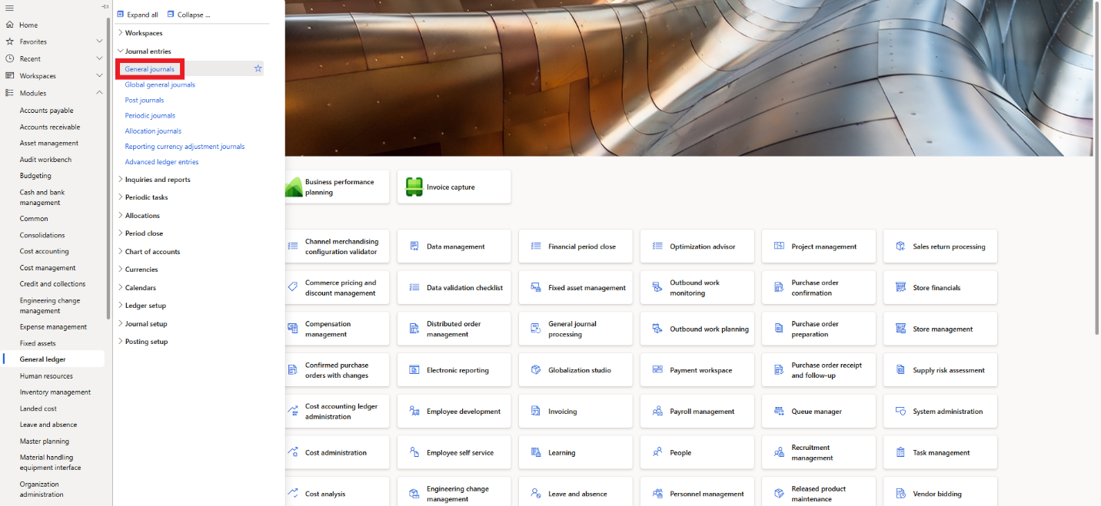

* On the **Action pane**, click **New**.
* In the **Name** field, click the drop-down button to open the lookup, and select the general journal name.
* Select the journal then click **Lines**.

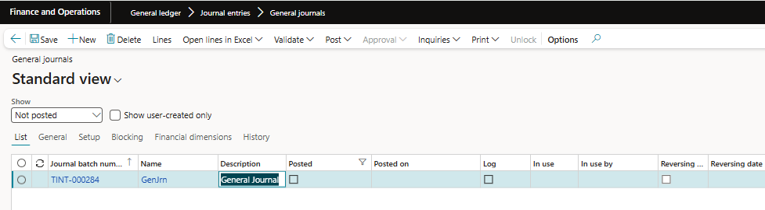

* In the **Date** field select a date.
* In the **Company** field select the legal entity within which a transaction occurs.
* In the **Account type** field, select a type.
* In the **Account** field, specify the account.
* In the **Description** field, type a value.
* In the **Debit** or **credit** fields, enter the amount of the journal.
* Enter the **Offset company** if you are doing intercompany transactions. The **offset company** field is used for intercompany transactions where one company records an entry that must be offset in another company's general ledger.
* Select the **Offset account type**, then select the offset account in the **Offset account** field.
* In the **Currency** field select the currency.
* On the Action pane, **Validate** the journal, then **Post**.

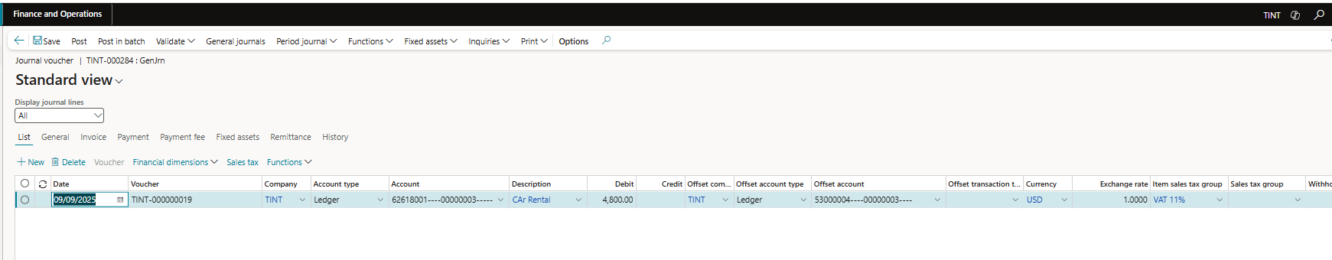

General Ledger Accruals



**3**

# 3. GL Accruals

## 3.1. Accrual creation

* Navigate to **General ledger > Journal Setup > Accrual Schemes.**

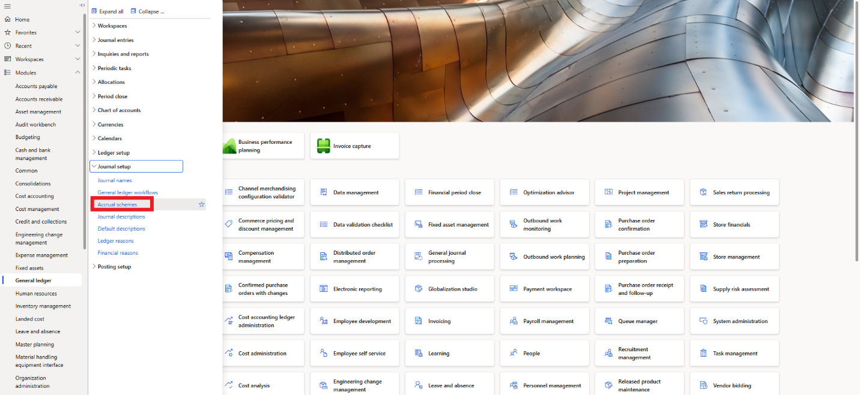

* Click on **New** in the action pane.
* Enter the name you want to give to Accrual Scheme in **Accrual Identification**
* Enter description of Accrual Scheme in **Description of Accrual Scheme**
* Click on **Debit** and enter Account you want to get debited at the time of booking the prepaid entry. Usually, the account selected here will be the balance sheet Account where Advance or Prepaid will be recorded.
* Click on **Credit**and select the Main Account you want to Credit moving forward into the months i.e., the actual expense account.
* Click on **Voucher** and from the dropdown menu select **New voucher for each accrual transaction date.**
* Click on **Number sequence code** and select appropriate number sequence.
* Click on **description**and add description for the Accrual Scheme.
* Click on **Accrual Basis** and form dropdown select **Calendar.**
* Click on **Period Frequency** and from drop-down select Monthly. For this transaction we want to post Accrual journal every month that is why we have selected Monthly.
* Click on **Number of Occurrences by Period** and enter period. Here, we want to post Accrual Journal for 6 Months that is why we have selected Number of Occurrences as 6. If you want to post for 12 months, then enter ‘12’ here and so on.
* Click on **Post Transaction** and from drop-down menu select Month.
* Click on **Post in Week, Month, or quarter** and from the dropdown lost select one of these three options:
  + **Beginning**: 1st of every month.
  + **Middle**: 15th of every month.
  + **End**: 30th /31st of every month.
* Click on **Spread Month and Quarter Values** and select one of these two options:
  + **Evenly**: Divide the total amount equally according to months mentioned.
  + **Number of days**: Calculated the amount according to the no. of days.
* Click on **Save.**

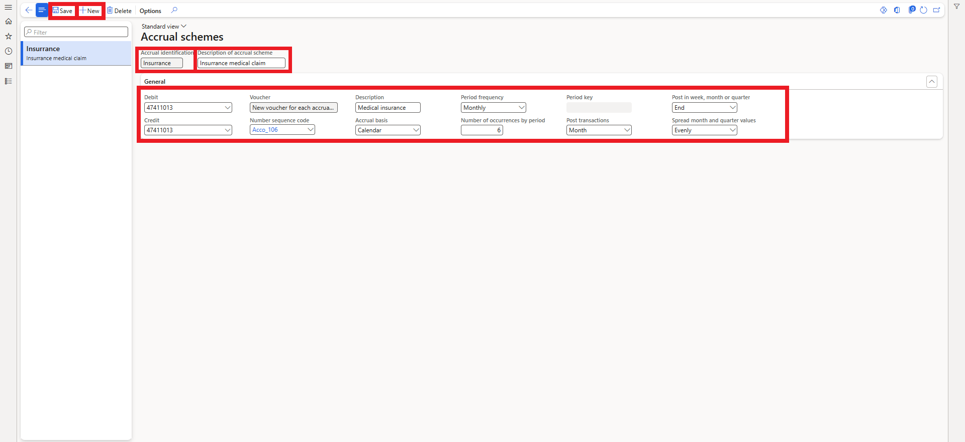

## 3.2. Vendor invoice

To create a vendor invoice journal, follow these steps:

* Nownavigate to **Account Payable > Invoice > Invoice Journal.**

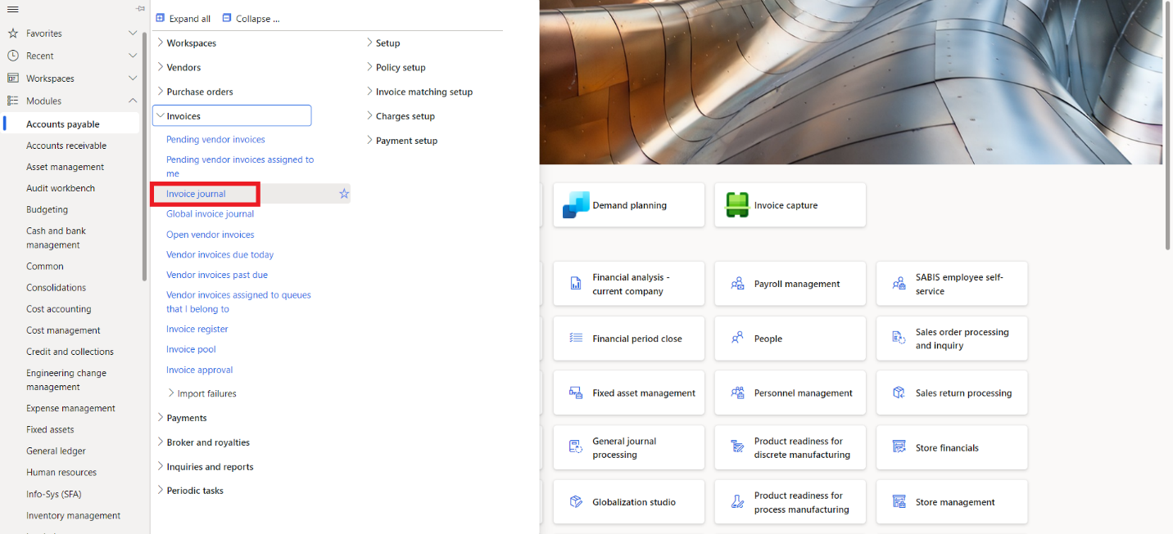

* Click on **New**
* Select **APInvoice** form dropdown.
* Click on **Lines**.

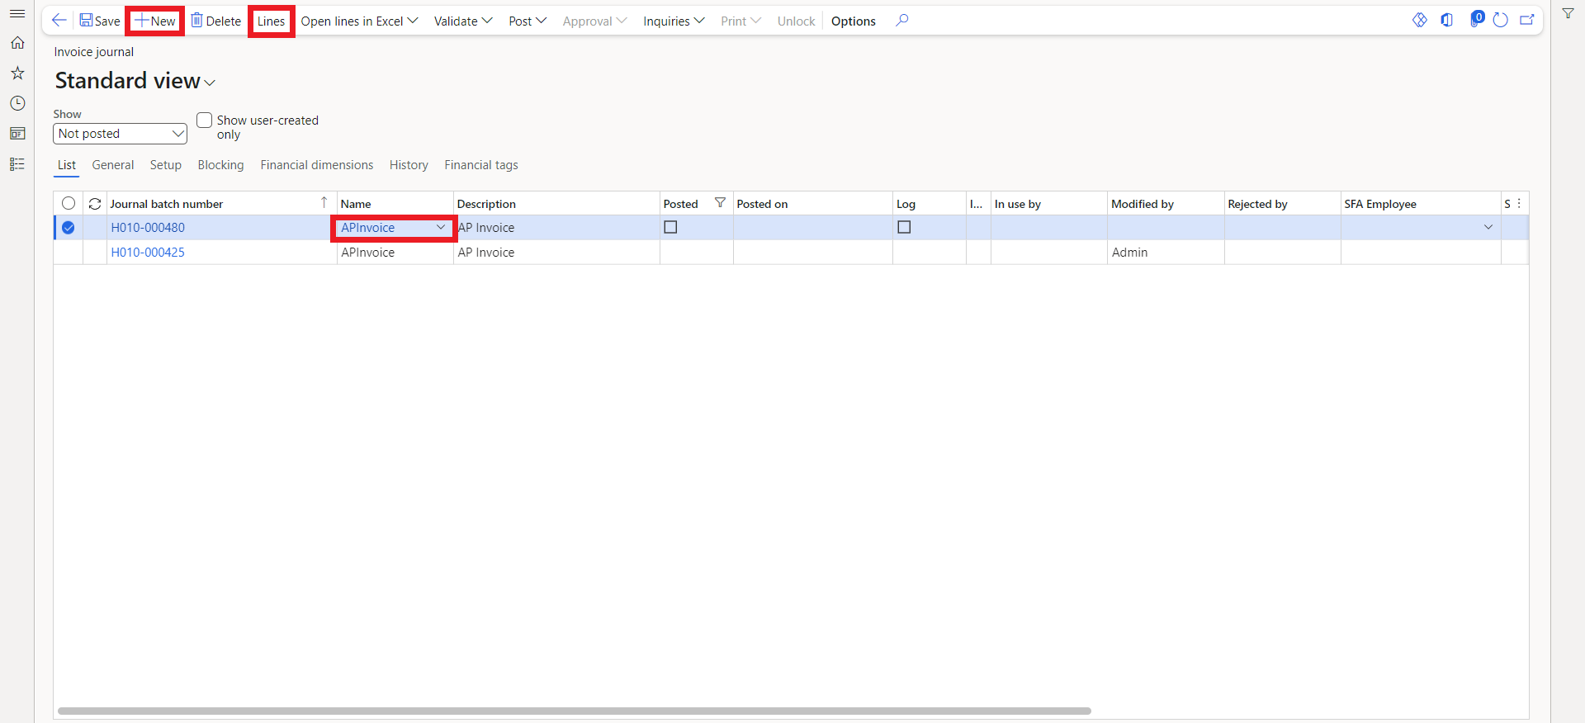

* Click on **Date** and select a date for the transaction.
* Click on **Account** and select the Vendor for the transaction.
* Click on **Invoice Date** and enter a date for the transaction.
* Click on **Invoice** and enter Invoice Number.
* Click on **Credit** and enter the amount.
* Click on **Offset Account** and select Offset account along with the **financial dimensions**.
* Click on **Validate** and simulate Posting. If no error occurs, we are good to go.
* Click on **Post.**

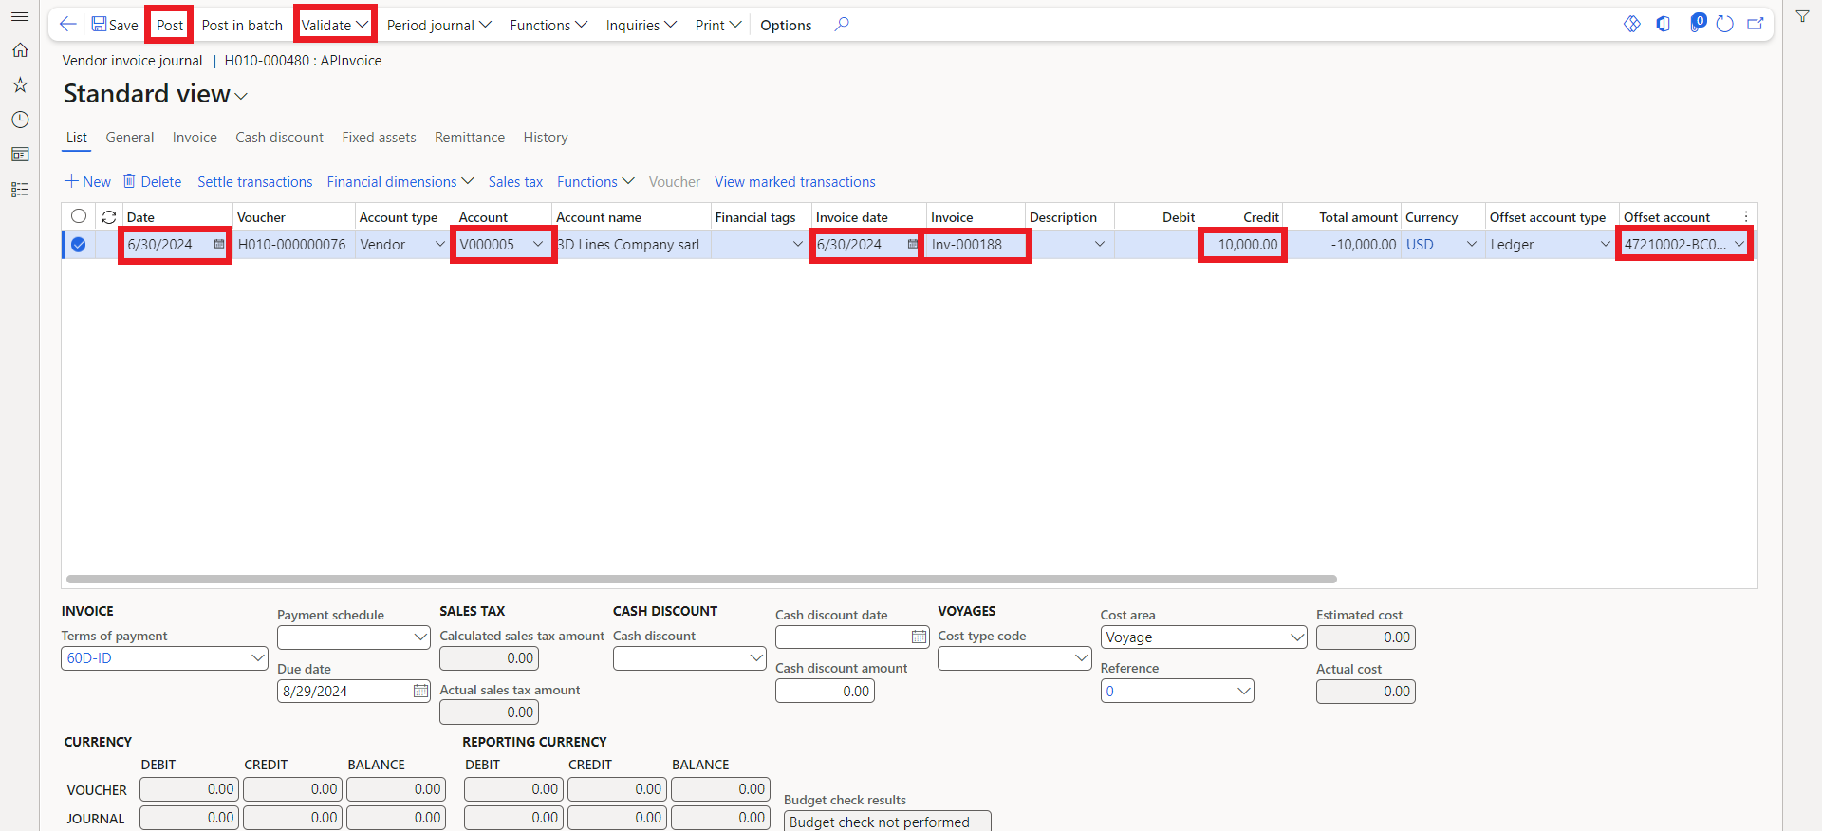

## 3.3. Accrual amount distribution

To create a GL journal and distribute the accrual amounts, follow these steps:

* Navigate to **General ledger > Journal entries > General journals**.



* On the **Action pane**, click **New**.
* In the **Name** field, click the drop-down button to open the lookup, and select the general journal name.
* Select the journal then click **Lines**.

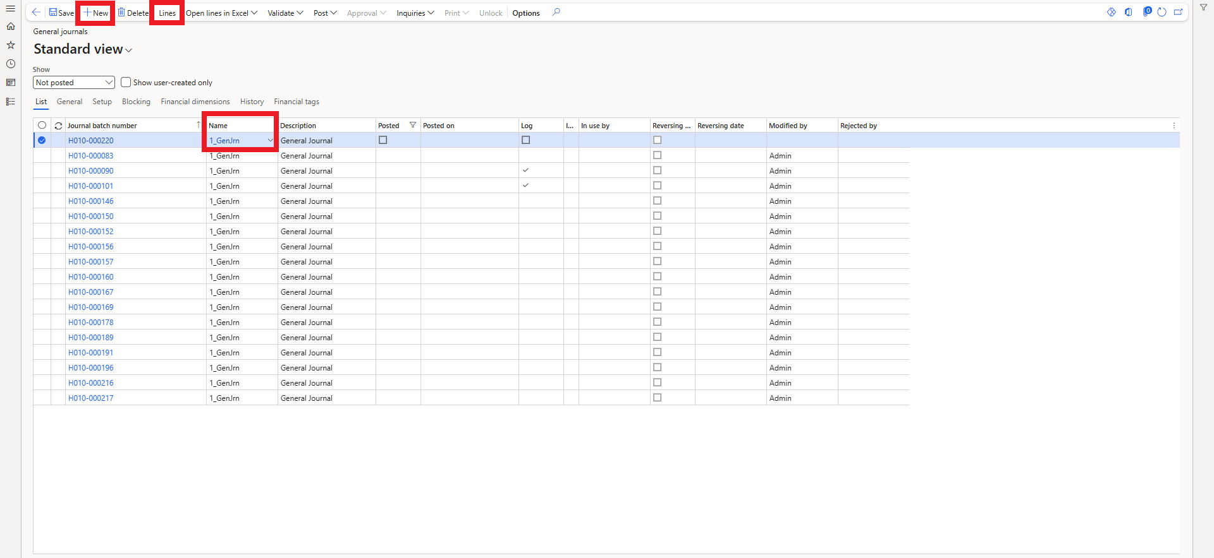

* In the **Date** field select a date.
* In the **Account** field, specify the account.
* In the **Description** field, type a value.
* In the **Debit** fields, enter the amount of the journal.
* Select the **Offset account type**, then select the offset account in the **Offset account** field.
* Click on **Functions** just above the Journal Line.

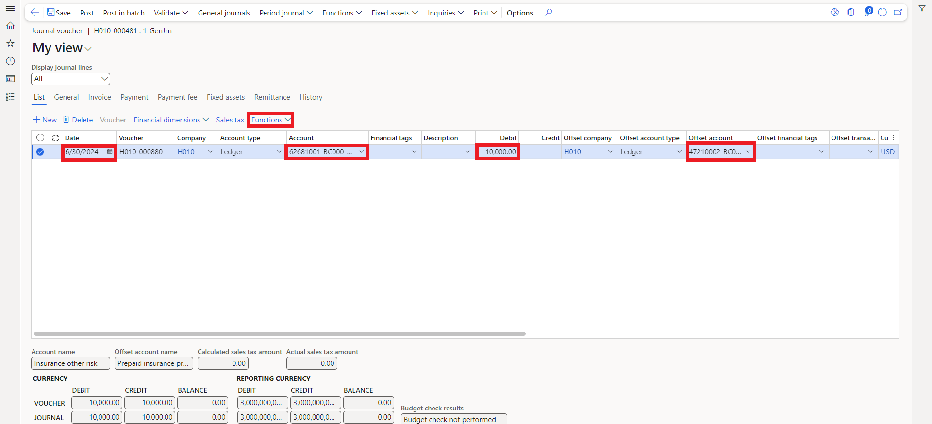

* Click on **Ledger Accrual** from the dropdown menu.
* A new side window will open.
* Click on **Accrual Identification** from dropdown select the Accrual Scheme which you want.
* Other details will reflect automatically. You do not need to change it manually unless necessary.
* Select if the **Accrual account** is in the **account** field or in the **offset account** field.
* Click on **Transactions**to validate the transactions for Accrual Scheme. After that, press on **back** and you will be back to side window of Accrual Scheme.

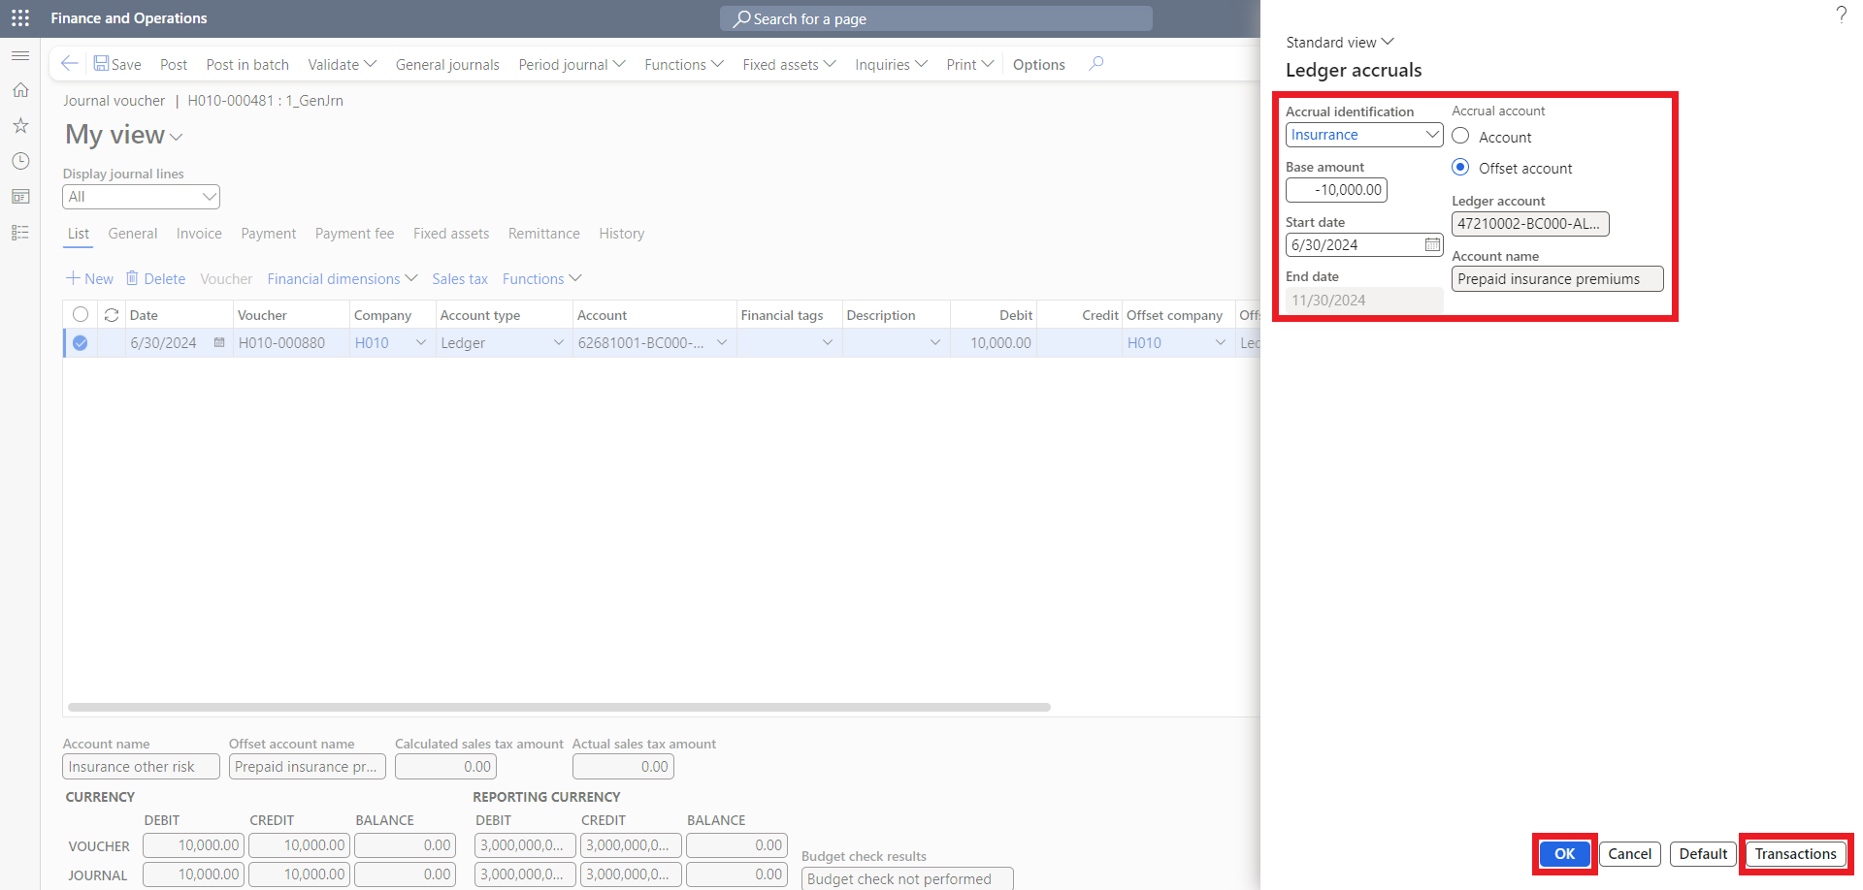

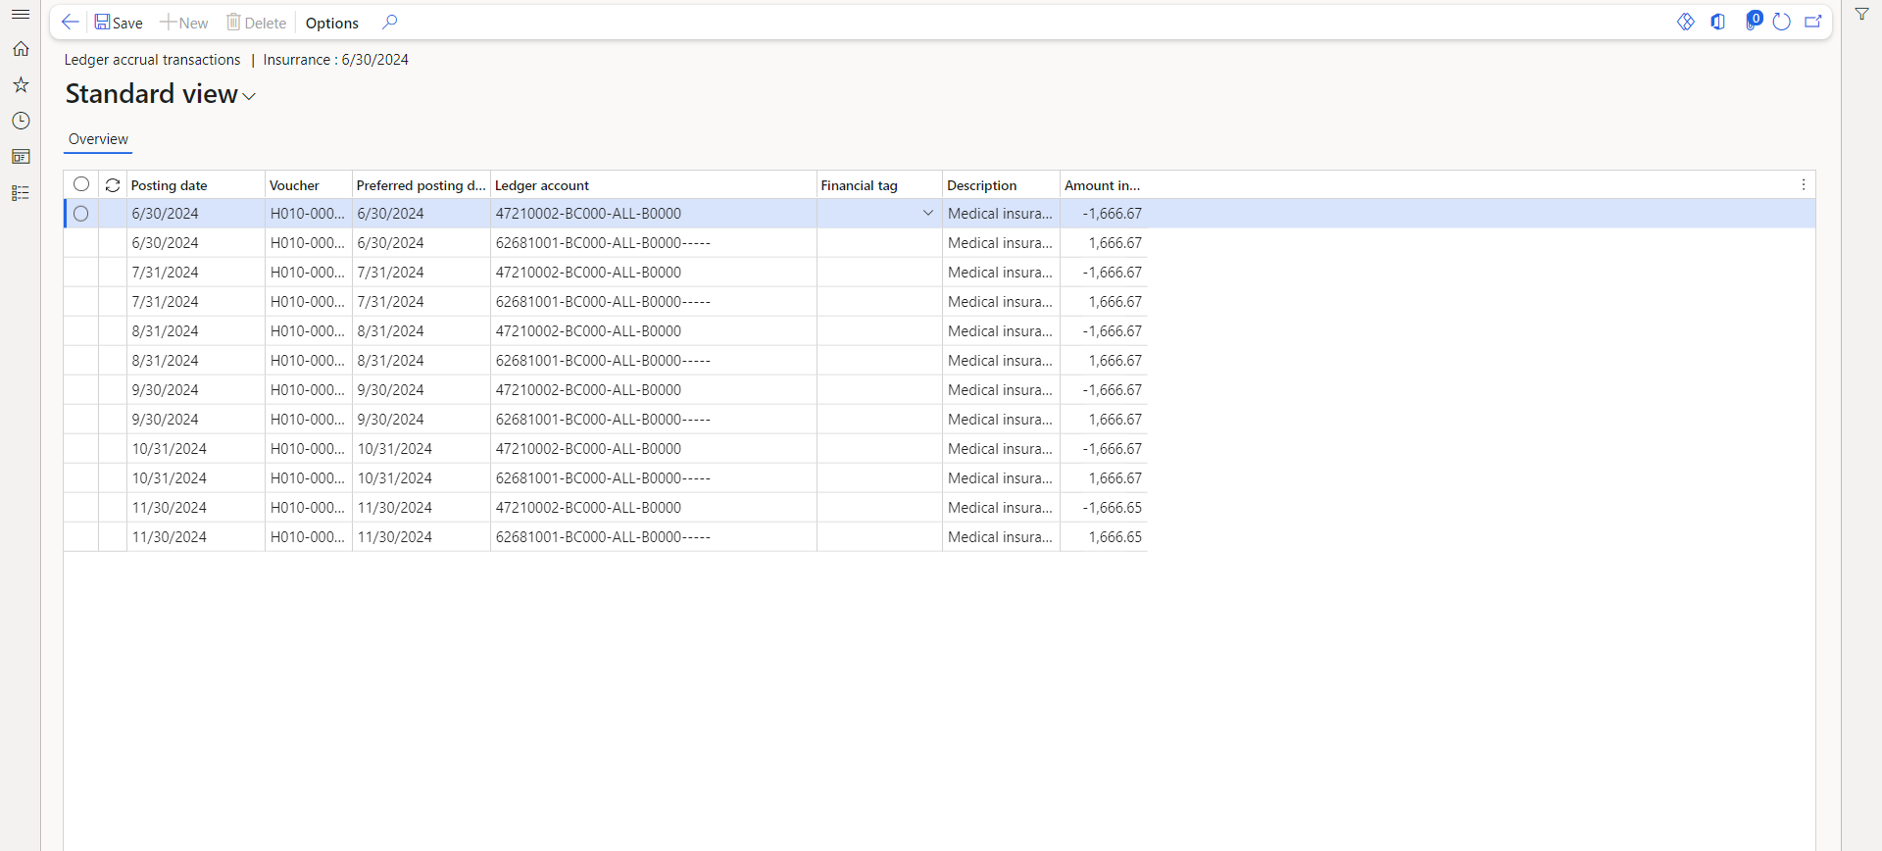

* Click on **Ok**to apply schedule on Invoice.
* After clicking **Ok,** Side window will close, and you will be back to the Journal Screen.
* On the Action pane, **Validate** the journal, then **Post**.

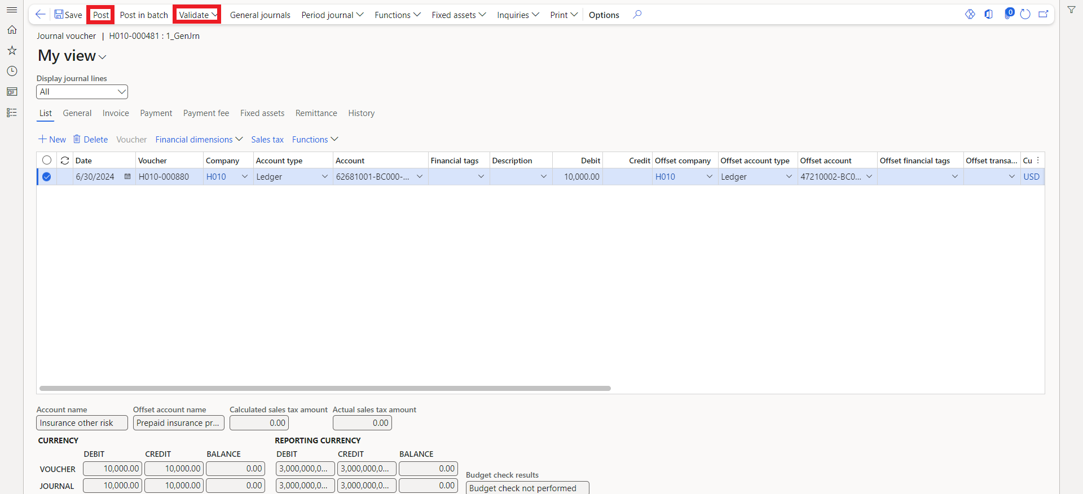

Periodic & Allocation journals



**4**

# 4. Periodic & Allocation journals

## 4.1. Periodic journal creation

* Go to **General ledger > Periodic tasks > Periodic journals**.

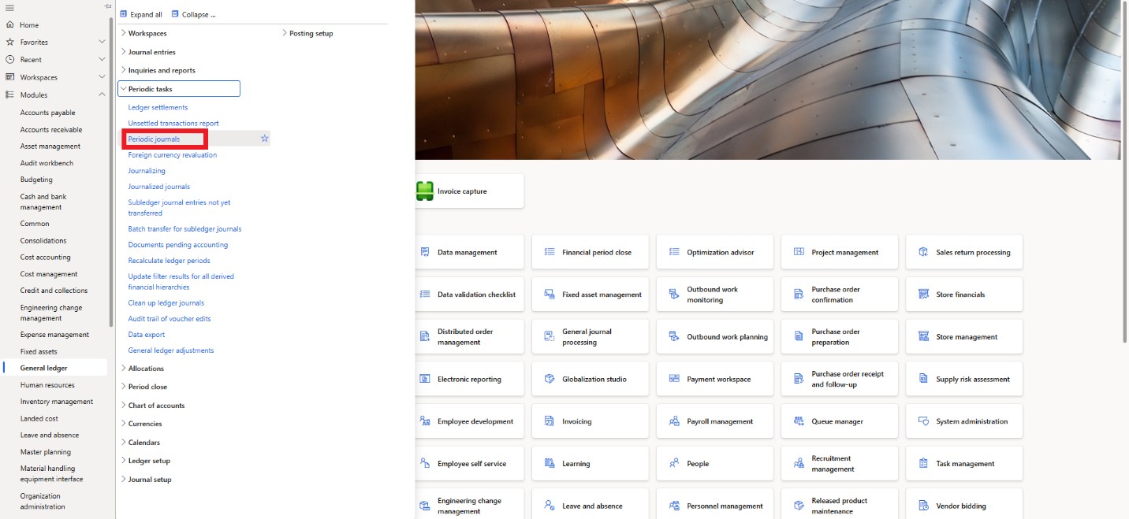

* Click **New**.
* In the **Name** field, enter or select the periodic journal name.
* In the **Description** field, type a value. The description will be the name of the **Periodic journal** when retrieved later so make sure to give it a relevant name.
* On the **Action pane**, click **Lines**. A periodic journal will typically include several journal lines. This task guide will however only add one line.

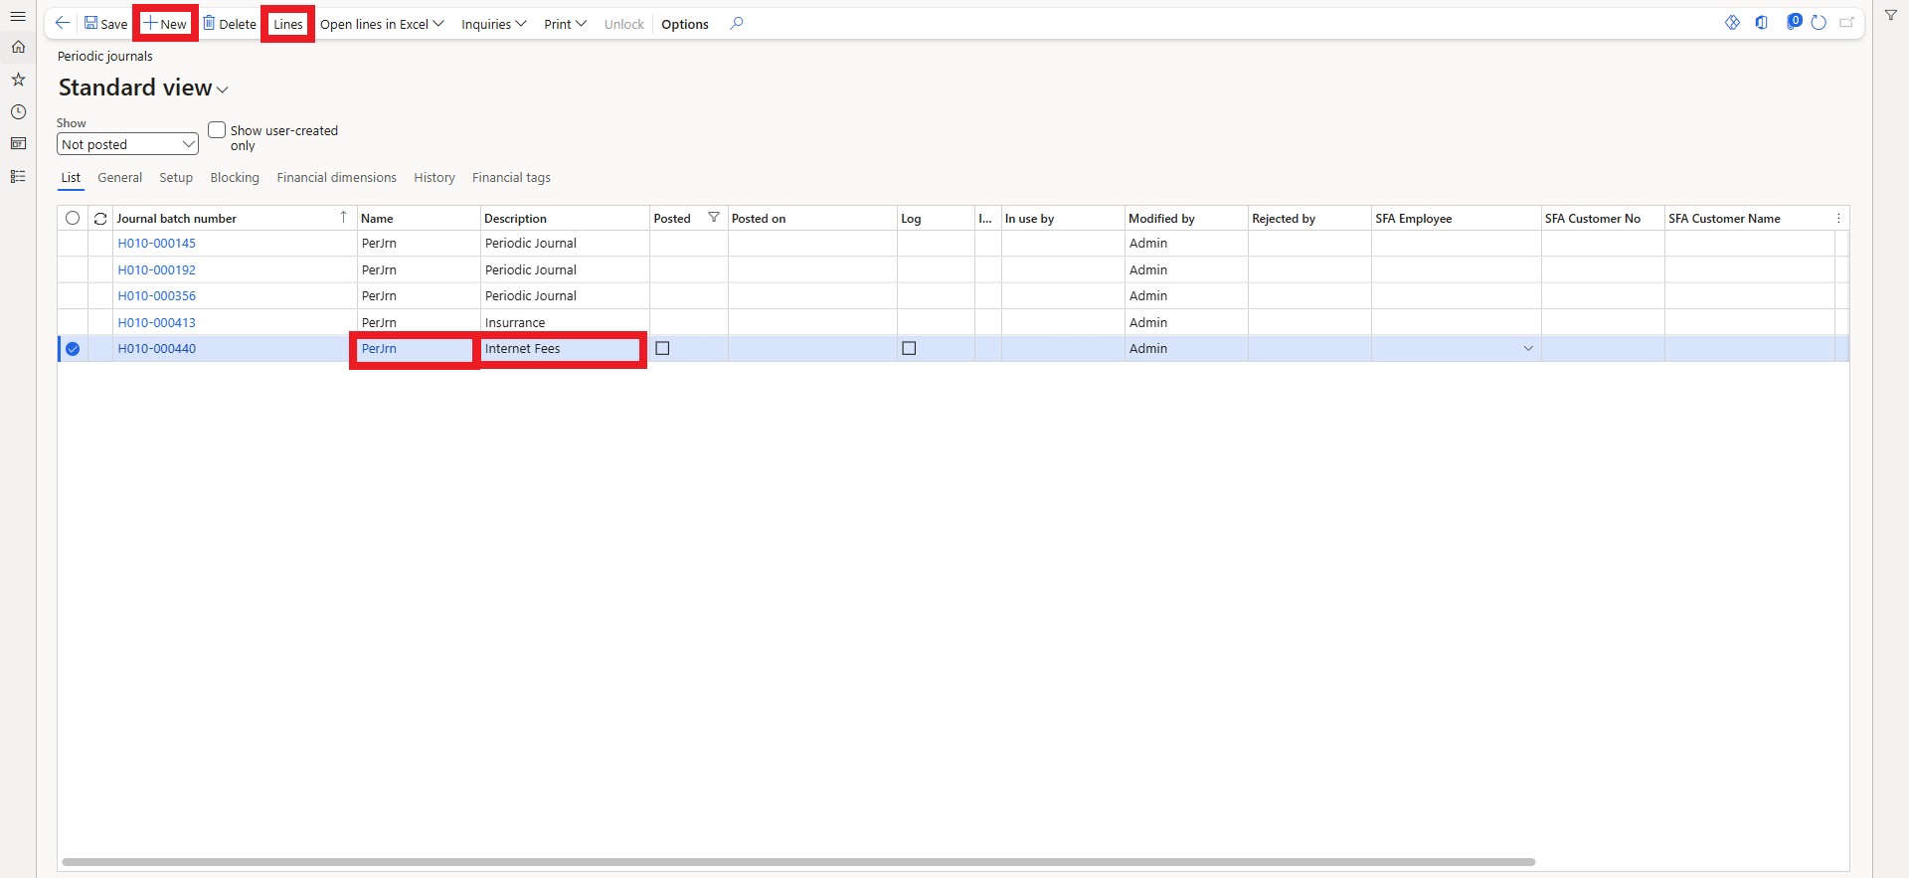

* In the **Date** field, enter a date. The **Date** field contains the posting date for the next transfer to the daily journal. For journals that will be retrieved each month, it's recommended to use the date in the month when it will be posted. This is typically the first or last date in the period. Using the **Empty date** field is possible to leave the **Date** field blank and give a date when the journal is retrieved. The field will be updated to the next recurring date when transactions are retrieved.
* In the **Account type** field, select a type.
* In the **Account** field, specify the desired values.
* In the **Description** field, select a value.
* In the **Debit** or **Credit** fields, enter a value.
* Alternatively, you can leave them empty if you don’t know the amount and enter it when you retrieve the journal.
* In the **Offset account type** field, select a type.
* In the **Offset account** field, specify the offset account.
* In the **Unit** field, select **Days**, **Months, Years**.
* Enter the **number of units** select the frequency of recurrence of the journal entry.
* In the **Last date** field, enter a date. Entering last date in the preceding period will prevent that the recurring journal by mistake is created in the wrong starting period. Last date will later be updated each time the periodic journal is retrieved.
* Click **Save**.

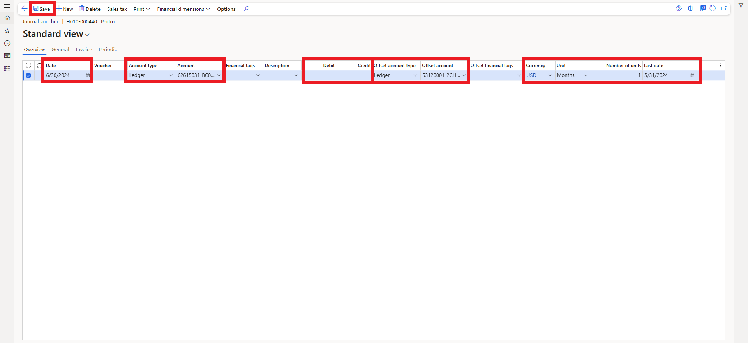

## 4.2. Periodic journals retrieve

To retrieve a periodic journal, follow the following steps:

* Go to **General ledger > Journal entries > General journals**.

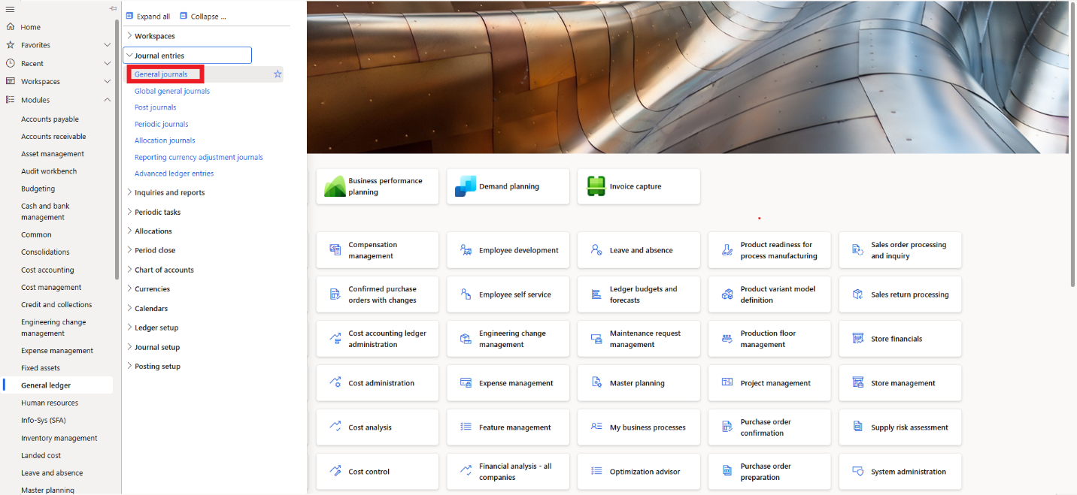

* Click **New**.
* In the **Name** field, enter or select a value.
* In the **Description** field, type a value.
* On the **Action pane**, click **Lines**.

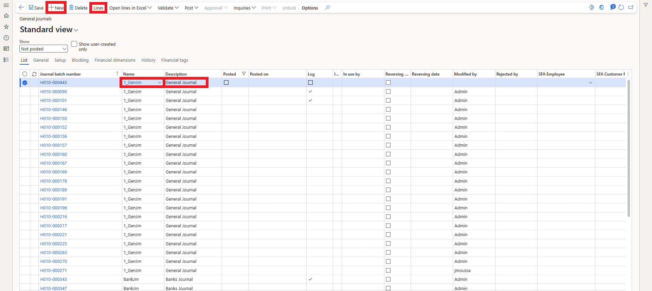

* The **general journal** page will open.
* On the **Action pane**, click **Period journal**.
* Click **Retrieve journal**.
* In the **To date** field, enter a date. The **To date** serves as the cutoff date for the periodic voucher lines. Based on the recurrence setting, the **Last date** and **To date**, the same line might be included more than once in the resulting journal. The **To date** is automatically updated based on the session date of the last time the periodic line was transferred to a journal.
* In the **Periodic journal number** field, enter or select the periodic journal.
* In the **Copy or Move Journal** field, if you choose **Copy**, the system will copy the periodic journal. If you choose **Move**, the system will move the periodic journal, and you will no longer be able to retrieve it.
* In the **From Date for Lines Without a Date** field, you can specify a date for the lines that you didn’t put a date for when creating the periodic journal.
* Click **OK**, to retrieve the journal.

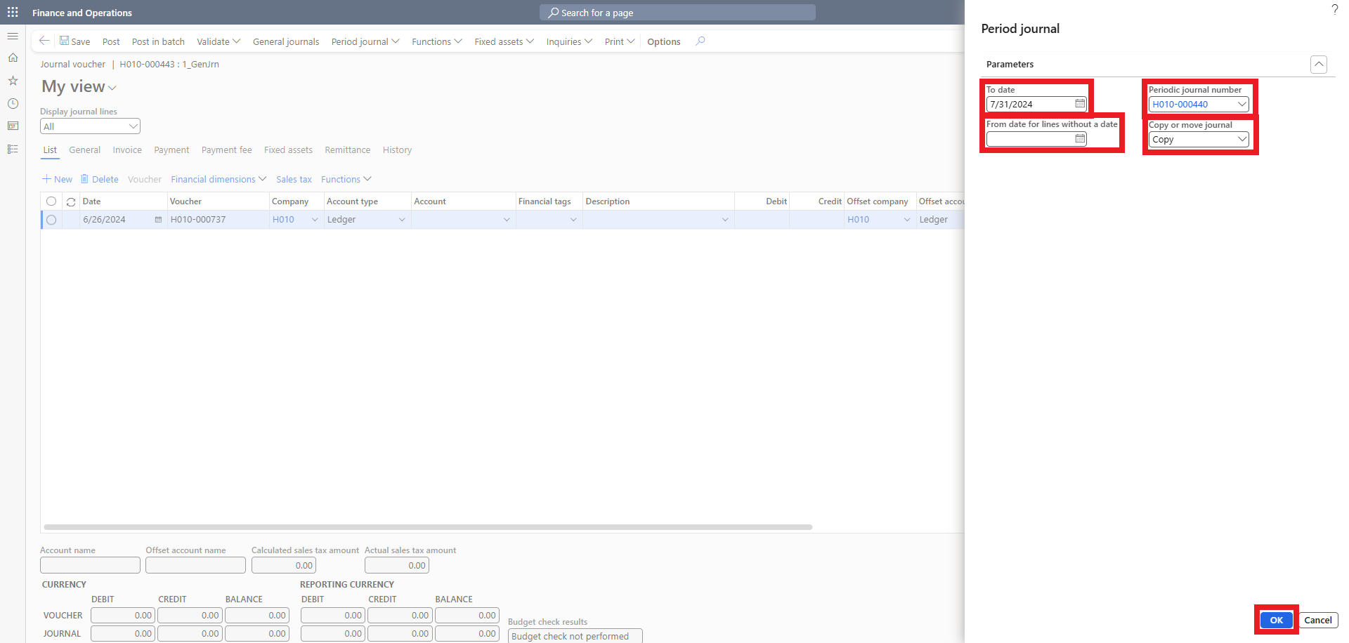

* Now you will be able to review the journal, fill the **Debit** or **Credit** fields, if you didn’t specify an amount when creating the periodic journal.
* Finally, you can **Validate** and **Post** the journal.

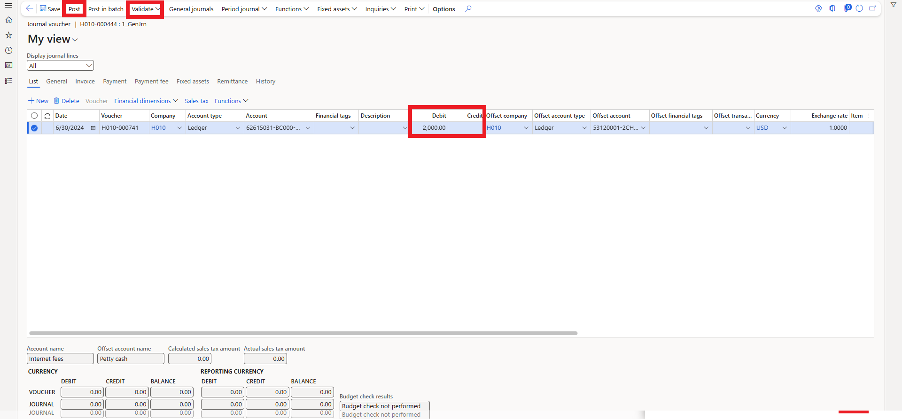

## 4.3. General Process Overview

You can create numerous periodic journals for various purposes in Dynamics 365. By saving these periodic entries with distinct names, you can easily identify and retrieve them later, streamlining your accounting processes. This feature allows for efficient management of recurring transactions.

## 4.4 Allocation Journals Rule

In Microsoft Dynamics 365 Finance, Allocations are used to distribute amounts (such as expenses or revenues) from one account or dimension to others, based on defined rules or percentages.

Allocations help ensure accurate and fair distribution of costs or income across departments, cost centers, or projects.

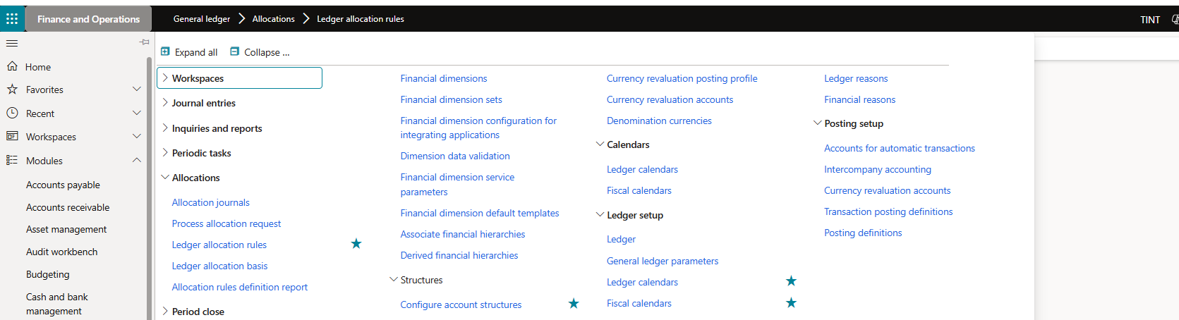

* Go to General ledger > Allocations > **Ledger allocation rules**
* Create a New Allocation Rule, Click **New**.
* Enter: **Name** example Office supplies
* **Description**: Office Supplies Allocation

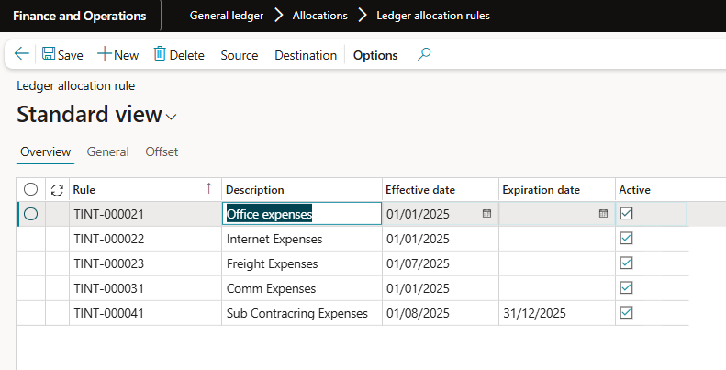

* Navigate to **General** Tab
* Set Effective date and Expiration date (optional).
* Allocation method: Fixed percentages

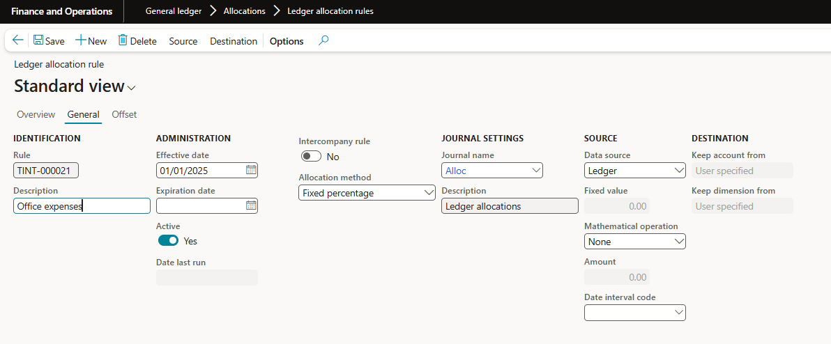

* Go to the **Source** tab to define Source: The source is where the amount to be allocated comes from.
* Enter: **Main account** or account range (e.g., 610100 – IT Expenses) Optional: Add financial dimension filters (e.g., Department = IT)
* Define **Destination**: This is where the amount will be distributed to.
* Go to the Destination tab. Add lines with:

Main account

Dimension values (e.g., Dept A = 30%, Dept B = 70%) Enter percentages or basis method.

In case the amount will be sent and split into 2 different percentage then you must fill 2 percentages with the account to and the related financial dimension if any

## 4.5 Allocation Journal Process:

* Go to General ledger → journal entries → Allocation journals.
* Click on Process allocation request.
* Fill the below data (Rule, GL posting date)
* In case you want to issue this allocation just a proposal without posting you may choose another proposal option like “Proposal only” → click ok

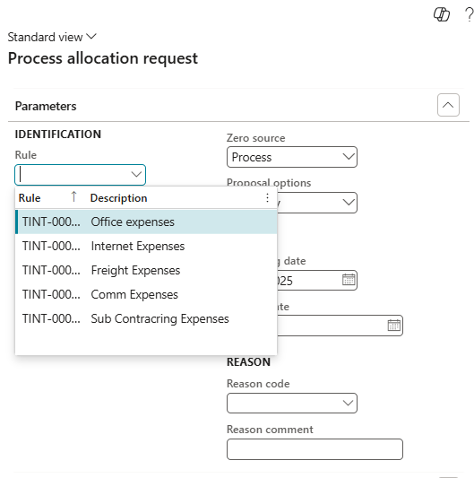 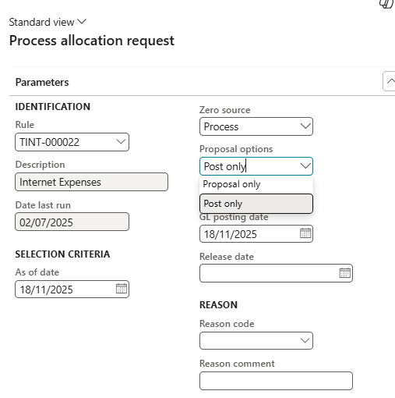

* If there is no accounting entry on the source account, the system will not bring any entry.
* But there is any, the system will write the below entry, then POST.

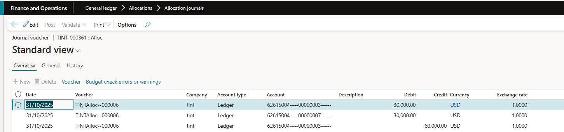

Month end close



**5**

# 5. Month End Close

## 5.1. Financial period close configuration

First, let's navigate to **General Ledger > Period Close > Financial Period Close Configuration**. From this screen, we will work on the configurations from the bottom up and start with defining closing roles.

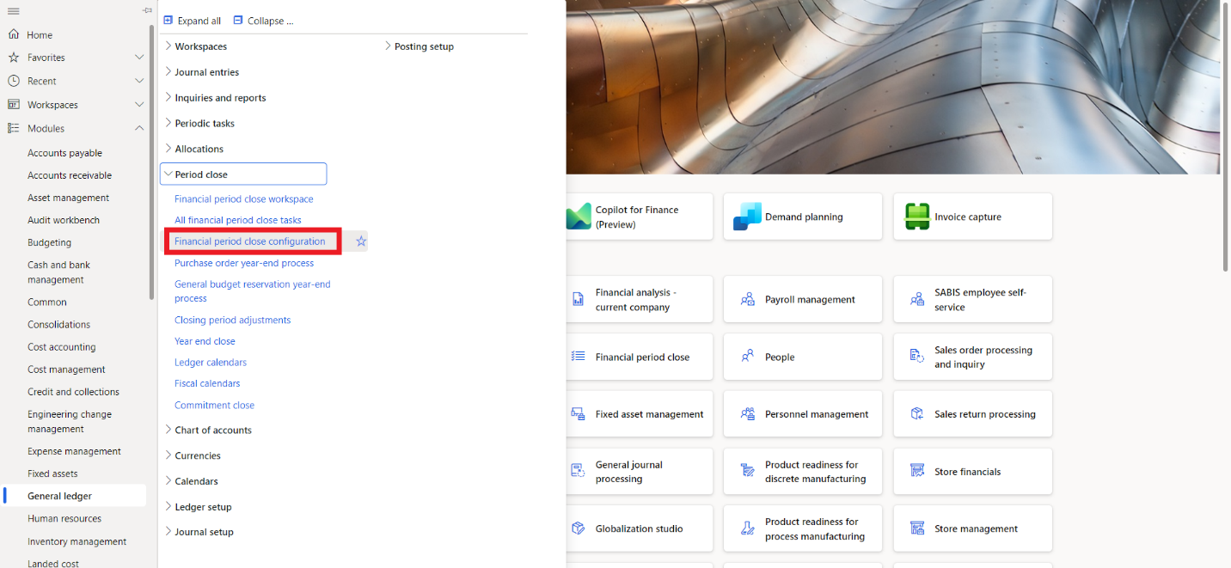

**Closing Roles**:

Closing roles are not the same as the security roles set up in the system. These are user-defined and particular to the roles you think you will need for your closing process. This is helpful because it will allow you to filter through tasks by roles.

* Click **New** to create a closing role.
* Enter the **Closing Role** name and a **Description**.
* Click **Save**.

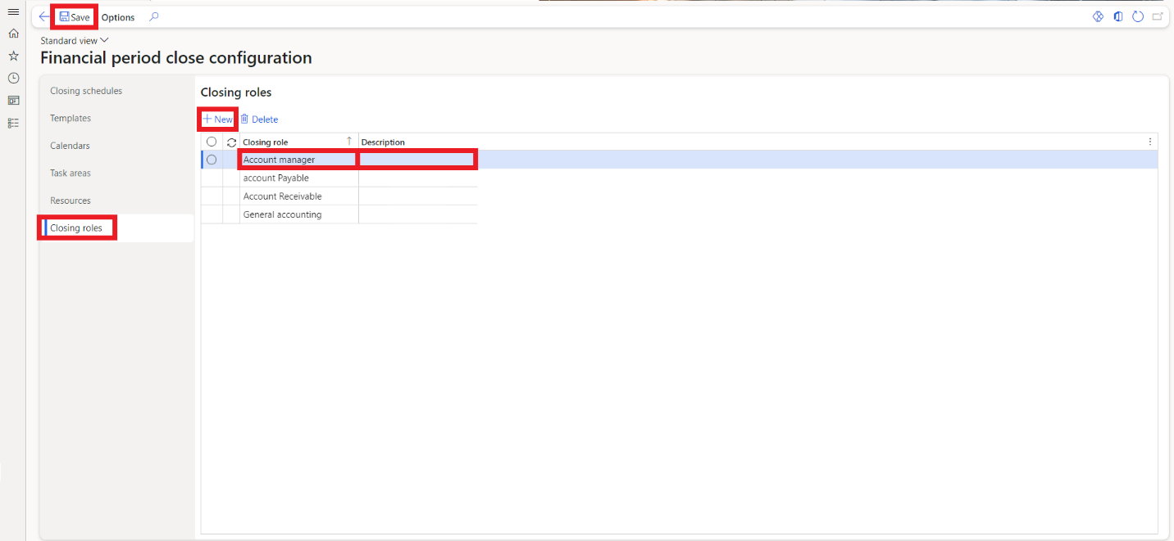

**Resources:**

In the Resources tab, you can then assign the roles you've just created to an employee. There is no limit to how many roles someone can have. However, roles can only be assigned to one person per company. Lastly, you can also select between allowing the employee to view All Tasks and Status or Only Assigned Tasks.

* Click **New**.
* Select an **Employee** from the drop-down menu.
* Select a **View**.
* Expand the **Closing Roles** FastTab if it is not already open.
* Click **Add**.
* Select the **Closing Role**.
* Choose the **Company** **(ies)** for that role.

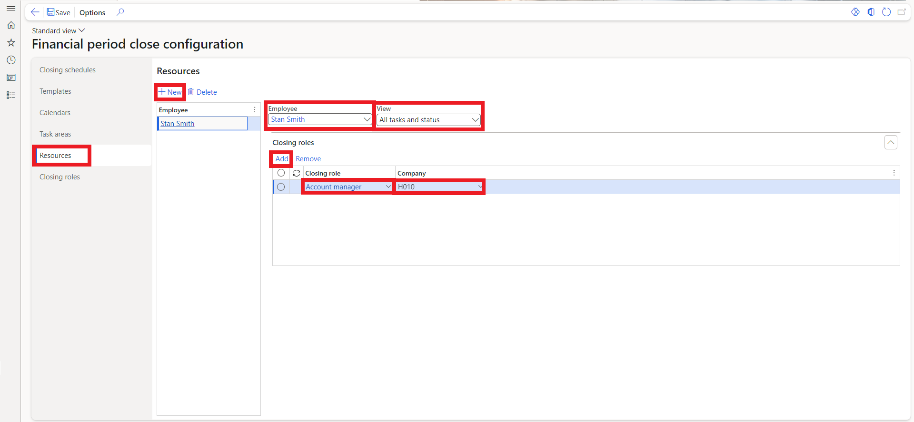

**Task Areas:**

Task areas are user-defined. It is up to you and your organization to determine how you would like to group task areas. Some examples are Accounts Payable, Accounts Receivable and General Ledger.

* Click **New**.
* Enter the **Area** name and a **Description**.
* Click **Save**.

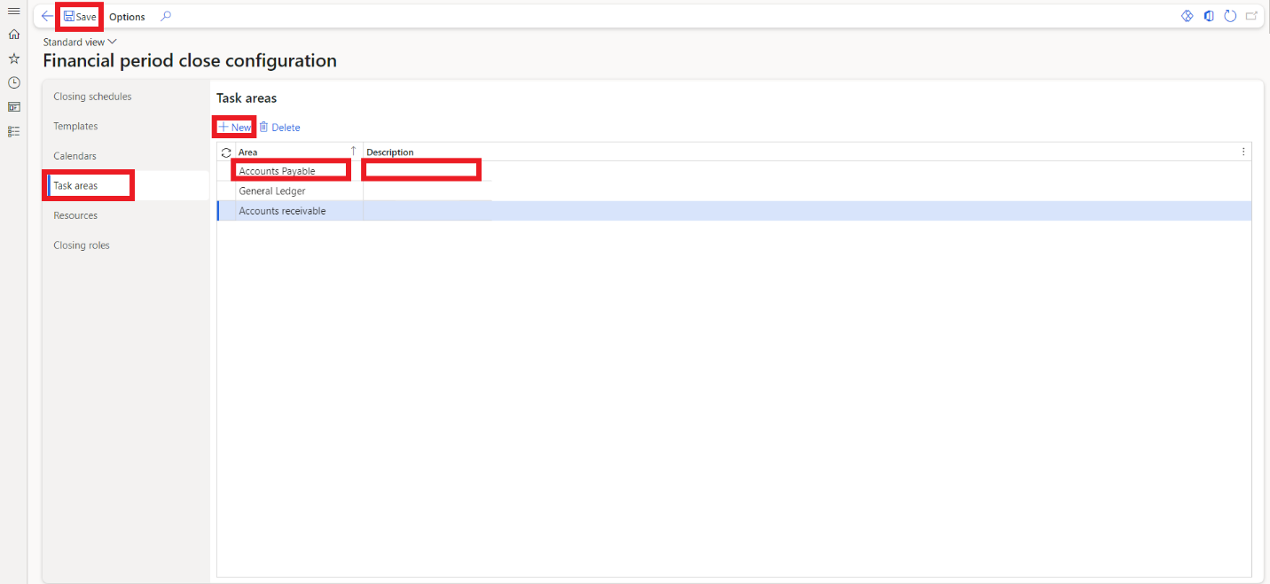

**Calendars:**

In the Calendars tab, you will create calendars that define the working days of your financial period closing process. These will be used for the scheduling of tasks. After you create the calendar, it can be edited, so you can go back and make any adjustments.

* Click **New**.
* Enter the **Calendar** title.
* Enter the calendar **Name**.
* Choose the **Start Date** of the calendar.
* Choose the **End Date** of the calendar.
* Then click **Create**.

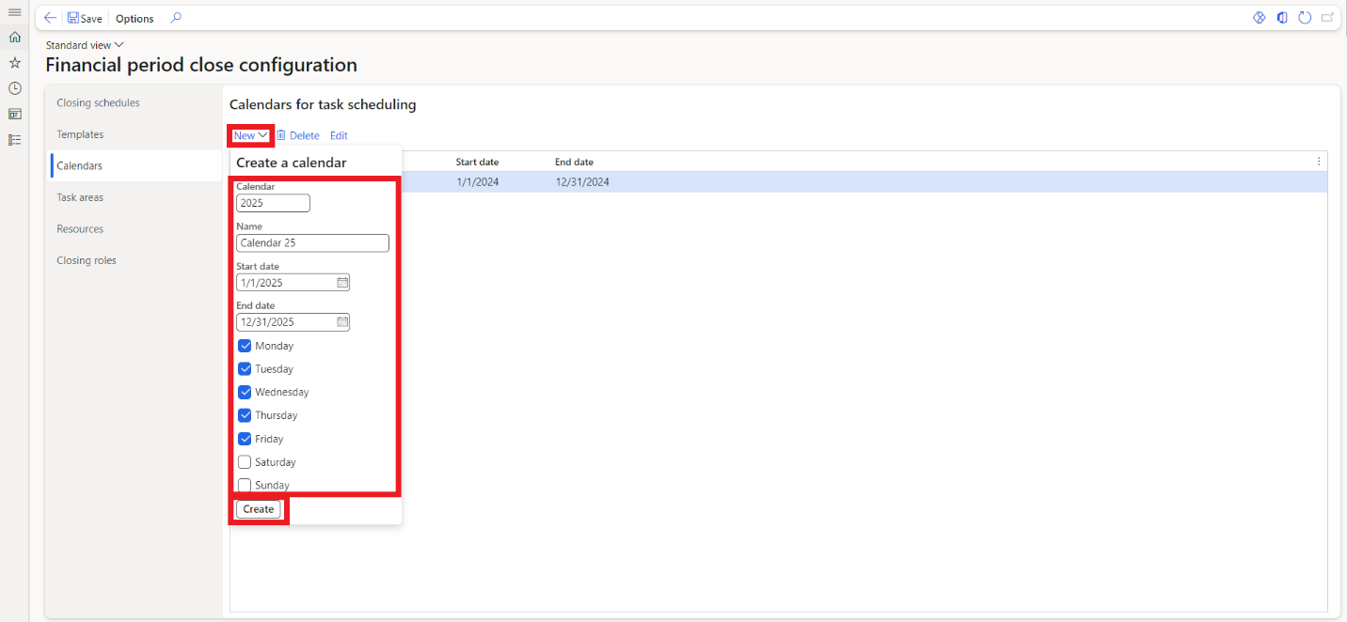

**Templates:**

A financial close template consolidates all tasks required for the closing process of a specific period. Separate templates can be created for several types of closes, such as month-end or quarter-end, and for different legal entities if their processes differ. If a new template is needed with minor modifications to an existing one, you can copy and rename the template, then adjust tasks, as necessary.

When setting up a template, tasks must be defined with relative due dates and times. Dynamics 365 calculates due dates based on a specified number of days before or after the period end date. The Task Link column enables you to link the relevant D365 page to each task, streamlining task completion. For example, a task to finalize period billing can link directly to the All-Sales Orders page for efficiency.

* Click the **+ icon** to create a new template and enter the **Template** name.
* Click **Create**.
* Click **New** to add tasks to the template.
* Select the **Area**.
* Enter the **Task**.
* Enter a **Due Date relative to the period end date (+/- days)**. Entering "0" sets the due date to the period end date, while "1" sets it to the day after.
* Enter a **Due Time**.
* Select the **Closing Role**.
* Select the **Company(ies)**.
* Select the **Task link** (the form or page in Dynamics to link the task to).
* To add **attachments or notes**, click on the three dots(**…**) and select **Attachments**.

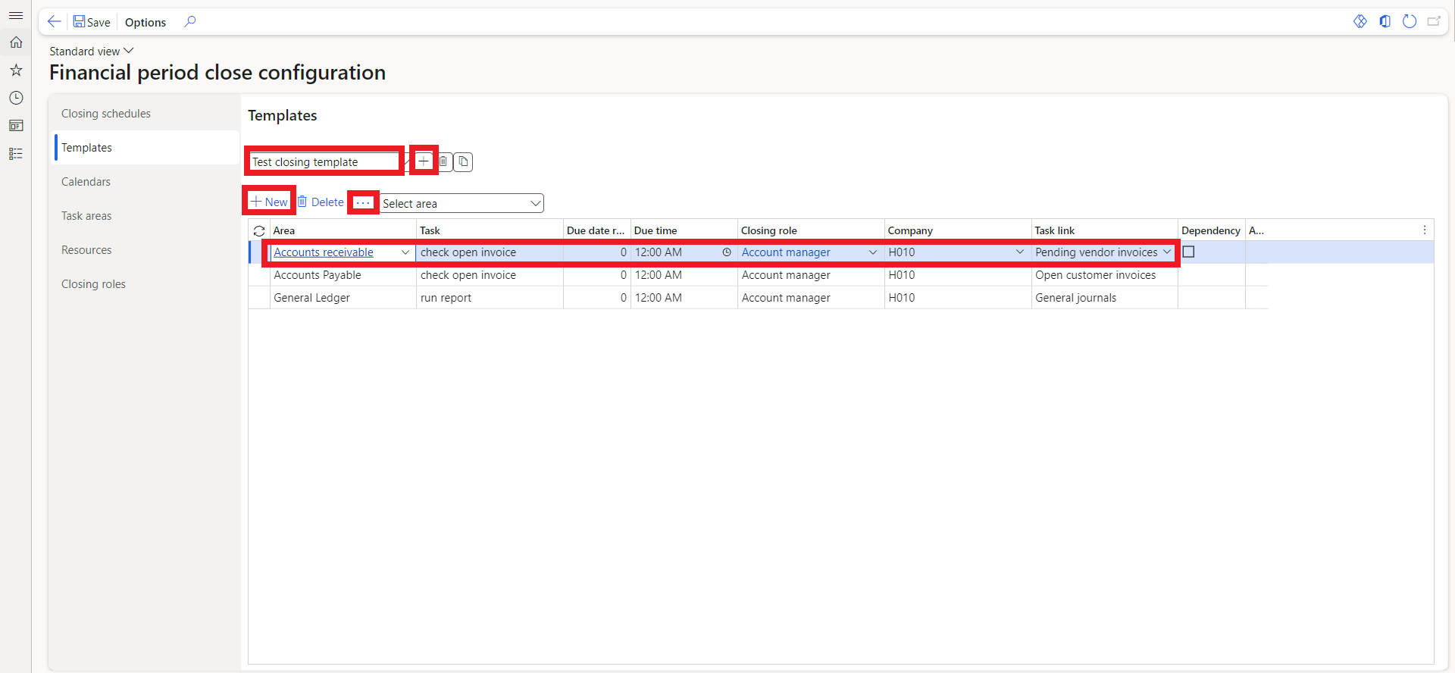

**Closing Schedules:**

Lastly, you need to create a closing schedule. Closing schedules are used to assign a template to a financial period that needs to be closed. When this is completed, the new closing schedule will be ready to be viewed in the workspace.

* Click **New**.
* Enter a name for the **Closing schedule**.
* Enter a **Description**.
* Enter the **Period Start Date**.
* Enter the **Period End Date**.
* Select the **Template** that you have previously created.
* Select a **Calendar**.
* Select the **Company(ies)** to include in the closing schedule.

When all tasks in a closing schedule have been completed, you are ready to select the Locked option. The newly locked schedule will then be removed from the workspace, but the completed tasks will remain accessible for visibility in the All-Financial Period Close Tasks list page.

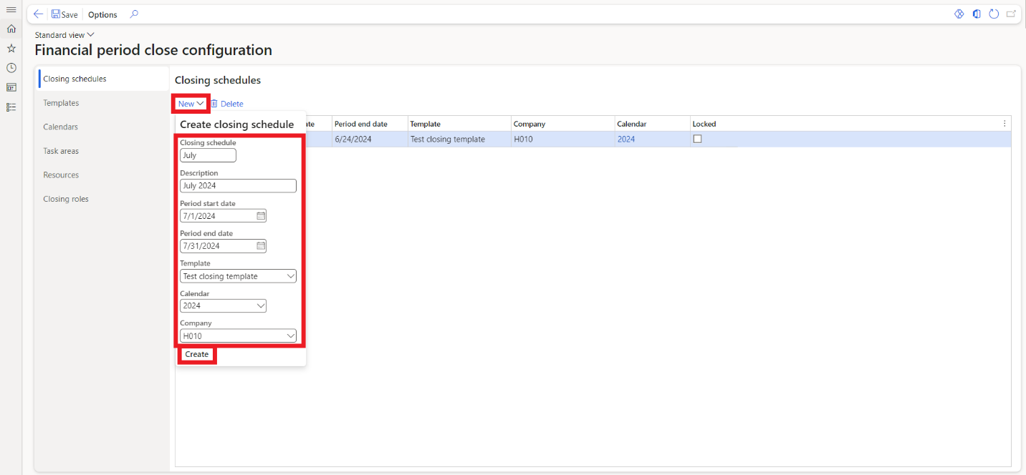

## 5.2. Financial period close workspace

The financial period close workspace is organized into three sections:

**Summary Tiles**: These provide an overview of tasks, including those that are past due, remaining, or blocked due to dependencies. Clicking on these tiles allows you to drill down further to see specific tasks. The tiles make action items immediately visible, helping to prioritize key tasks.

**Tasks and Status**: This section displays a filtered list of tasks and their statuses by company, area, and person. It can be personalized to show only tasks relevant to the user. You can expand the task list to see more details, and tasks marked with exclamation marks are past due, while those with padlocks are dependent on other tasks and cannot be marked complete.

**Helpful Links and Updates**: This section includes links to other useful pages. If you need to add tasks after creating a closing schedule, you must do so directly in the workspace. Changes made to the template won't reflect in already created schedules unless you delete the schedule, update the template, and recreate it.

To open the financial period close workspace, navigate to **General ledger > Workspaces > Financial period close.**

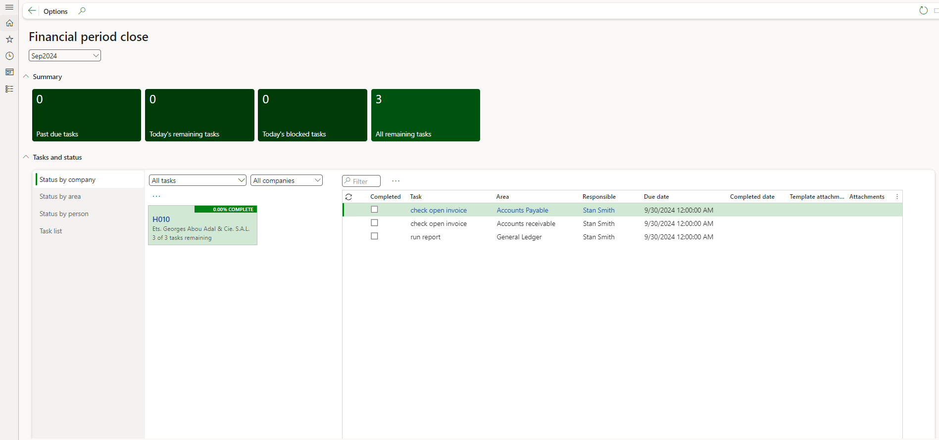

## 5.3. Period close process

* Navigateto **General ledger** > **Workspace** > **Financial period close** and ensure all tasks listed in the Period Close workspace are completed. This includes tasks assigned to different departments or individuals.
* Then go to **General ledger** > **calendars** > **Ledger calendars.**

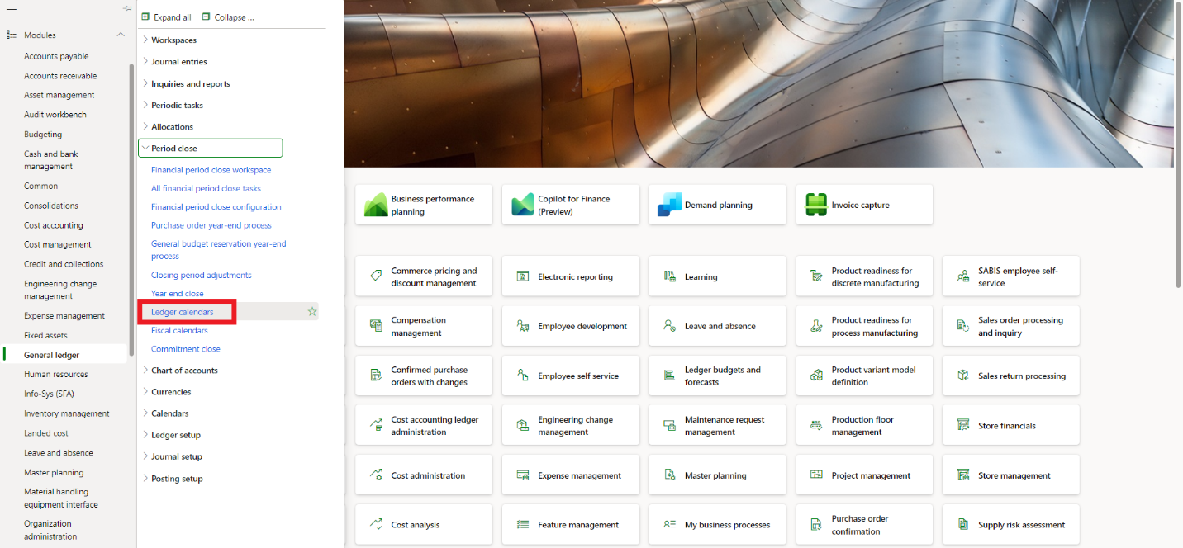

* For each ledger period, select the legal entities you want to close.

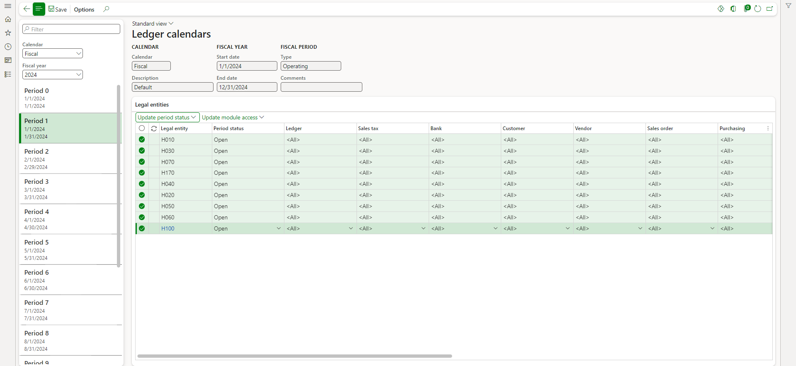

* Then click on **Update period status** and select “**On hold**” to prevent further posting.
* Avoid setting periods to “**Permanently closed**,” as they cannot be reopened.
* Finally, click **Update** to complete the process, and **Save.**

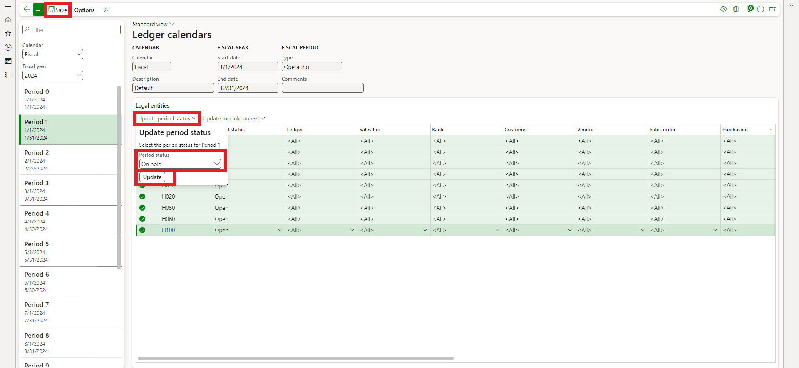

Year-end close



**6**

# 6. Year End Close

## 6.1. Year End Close Template Setup

* Navigate to the **General ledger > Ledger setup > Year-end close template setup.**

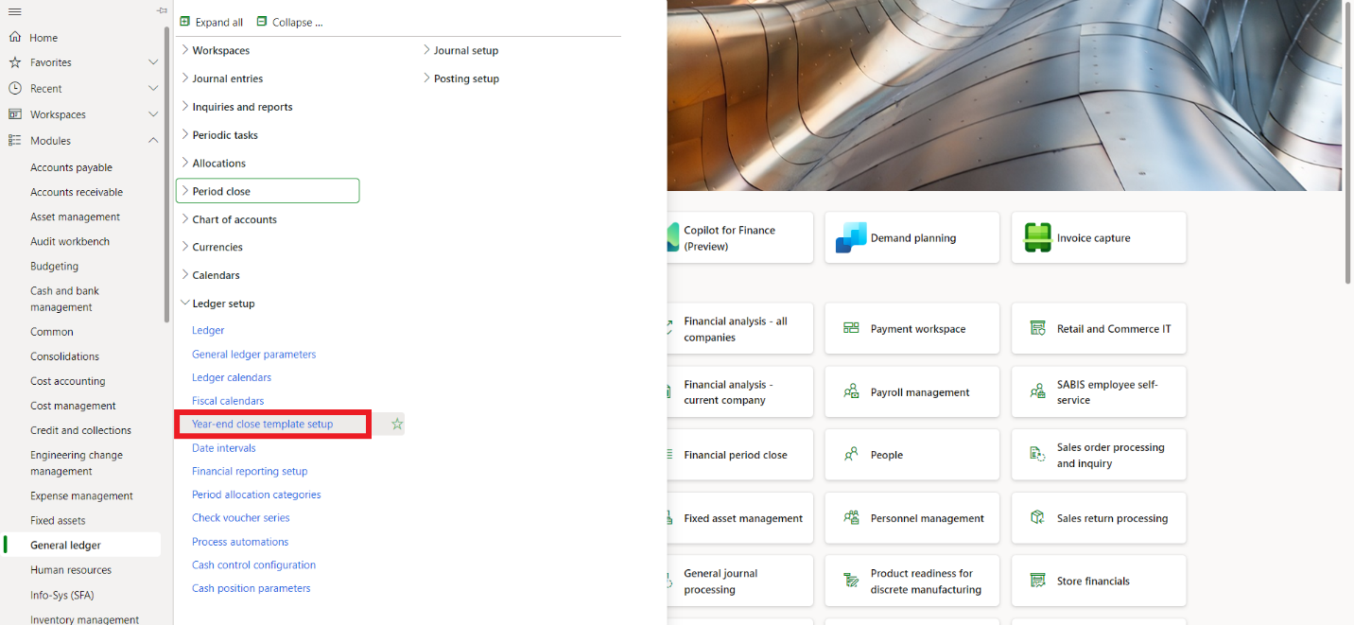

* Click **New** to create a year-end close template, a template can be created for a group of legal entities for which to run the year-end close. This template can be reused year after year.
* In the **Group name** field, enter a year-end close template name.
* In the **Fiscal calendar** field, select the fiscal year for which the template will be created.
* Only legal entities which use the same fiscal year can be grouped together in the year-end close template. On the **Action pane**, click **Save**.
* In the **Legal entities** section, click **Add** to select the legal entities for this template. Legal entities can be added by either selecting the legal entities or by selecting an organizational hierarchy.
* Select either the legal entities or the organizational hierarchy.
* Click **OK**.
* Select **Yes** or **No** in the **Transfer balance sheet dimension**. It's best practice to set this option to **Yes** for Balance sheet accounts. This will maintain the financial dimensions on posted transactions when creating the beginning balances for the balance sheet accounts.

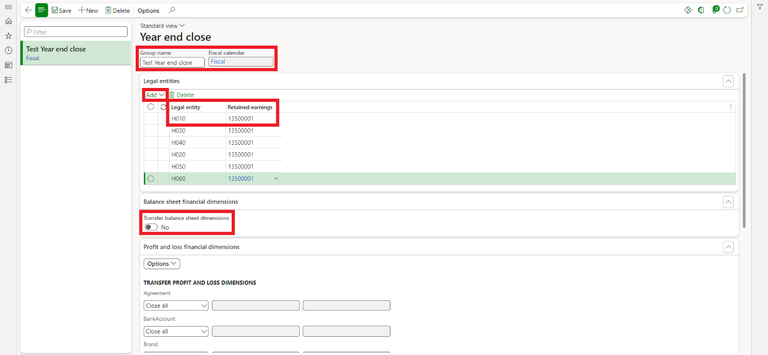

* For profit and loss accounts, you can select to maintain the financial dimensions (**Close all**) when the balances are moved to Retained earnings, or you can select to have the financial dimensions replaced with a different dimension value (**Close single**). If you choose **Close single**, you can define a specific dimension value for each dimension or even choose to leave it blank.

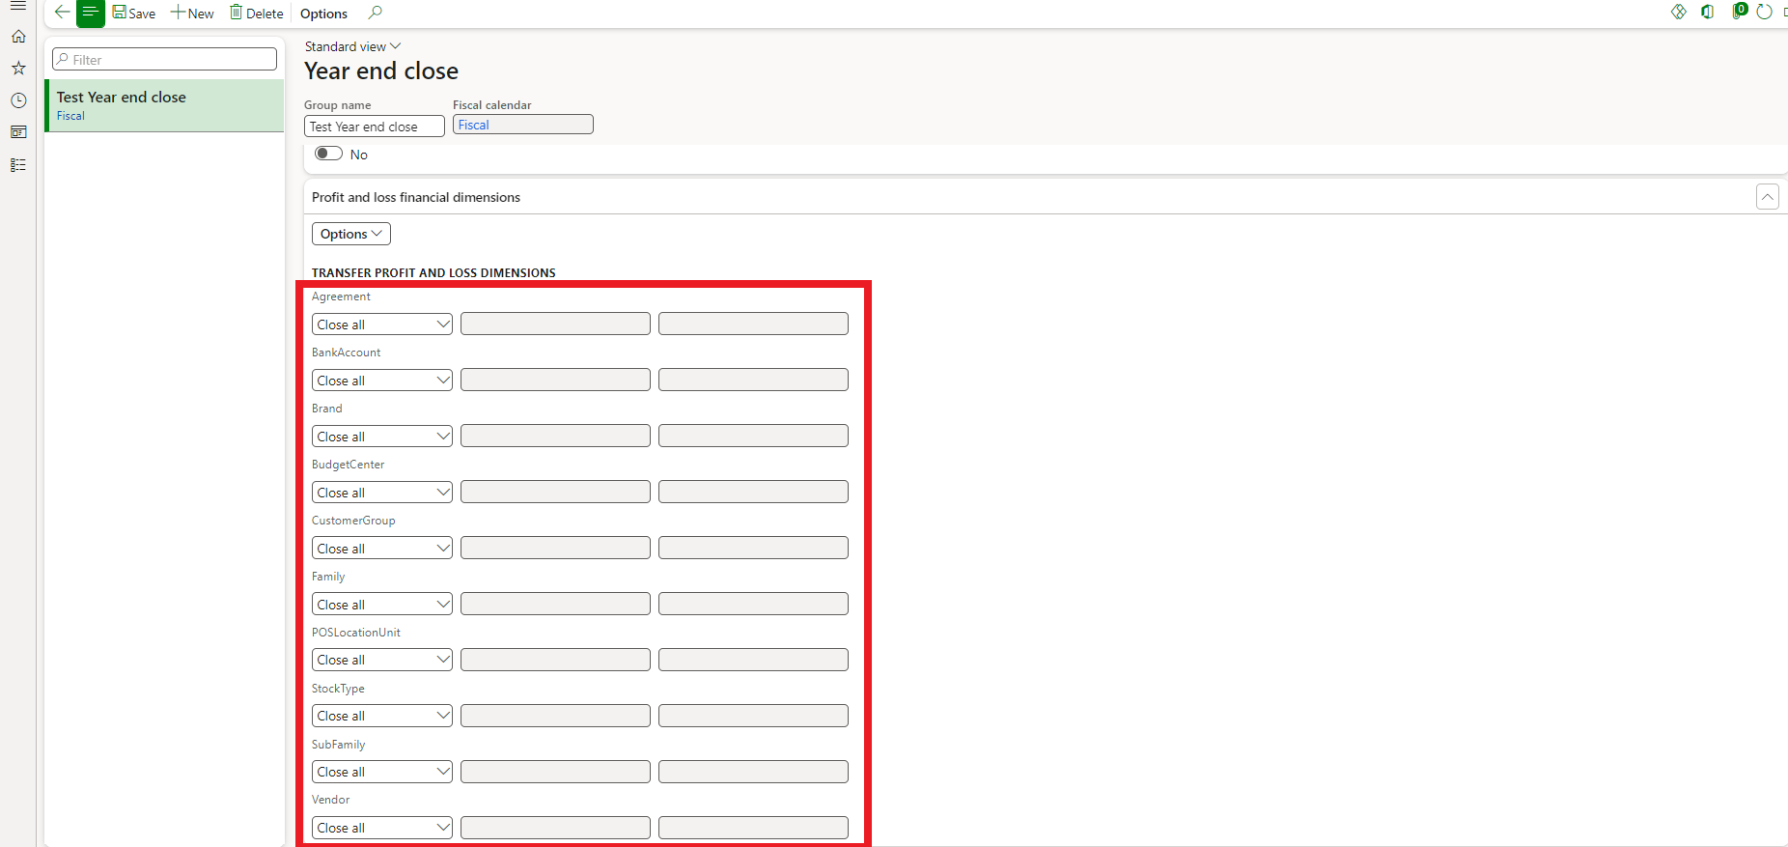

## 6.2. Year End Close process

* Navigate to the **General ledger > Period close > Year end close.**

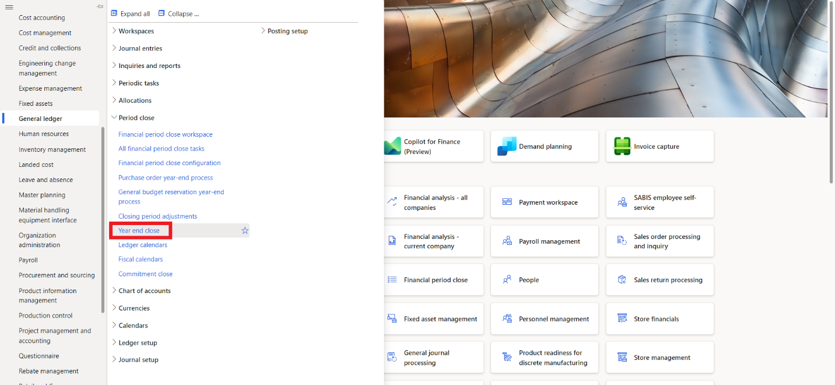

* Start the year-end close by choosing **Run year-end close** on the **Action Pane**. The year-end close will be run for the selected template.
* Select all or a subset of legal entities from the template for which to run the year-end close.
* Click **OK**.

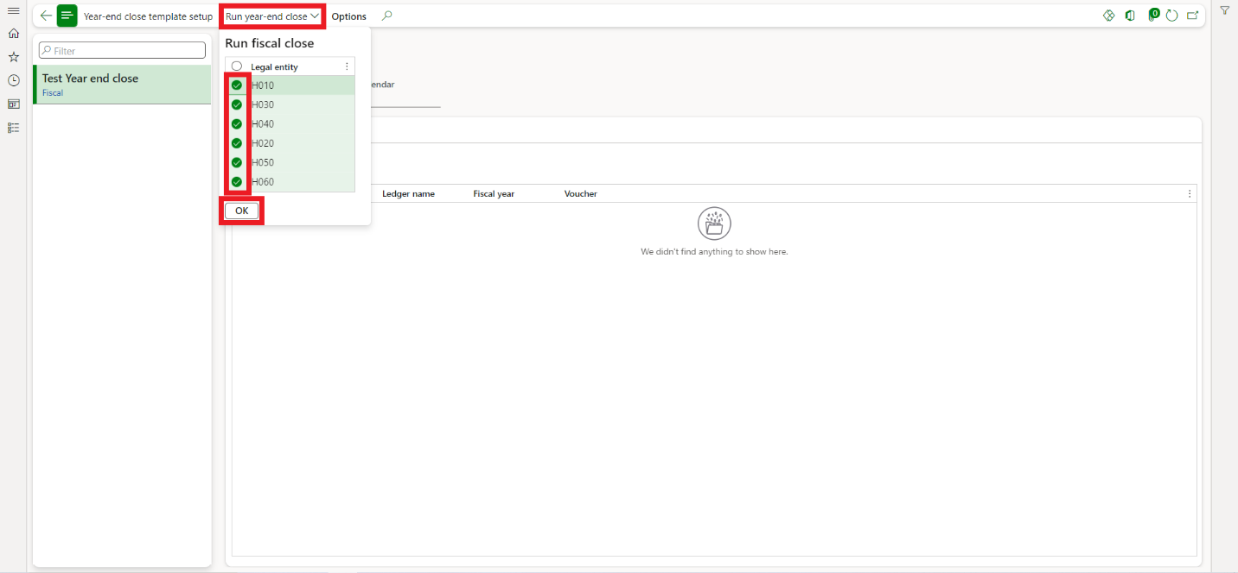

* Select the **Fiscal year** for which to run the year-end close.
* In the **Voucher** field, type a value. It's best practice to include the fiscal year in the voucher number, to make it easier to find the year-end close voucher that is created.
* The year-end close defaults to run in batch. It's best practice for long-running processes to run in batch mode. This is typically one of those processes, which is why the default is to use batch mode.
* Click **OK**.

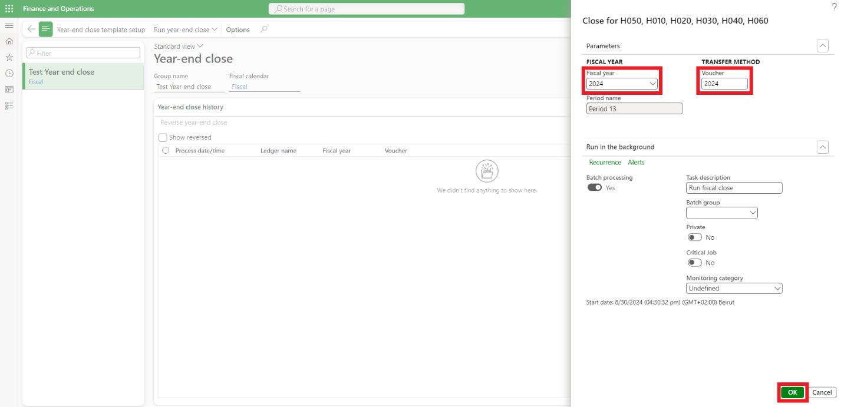

Foreign Currency Revaluation



**7**

# 7. Foreign Currency Revolution

In D365 Finance and Operations, the General Ledger foreign currency revaluation process adjusts the value of foreign currency balances in ledger accounts to reflect exchange rate changes. This ensures accurate financial statements by accounting for currency fluctuations, posting adjustments to the ledger for transparent reporting, and improving financial analysis.

To run the foreign currency revaluation in the General Ledger module in Dynamics 365 Finance and Operations, you can follow these steps:

* + - * Navigate to **General ledger > Periodic Tasks > Foreign Currency Revaluation**.

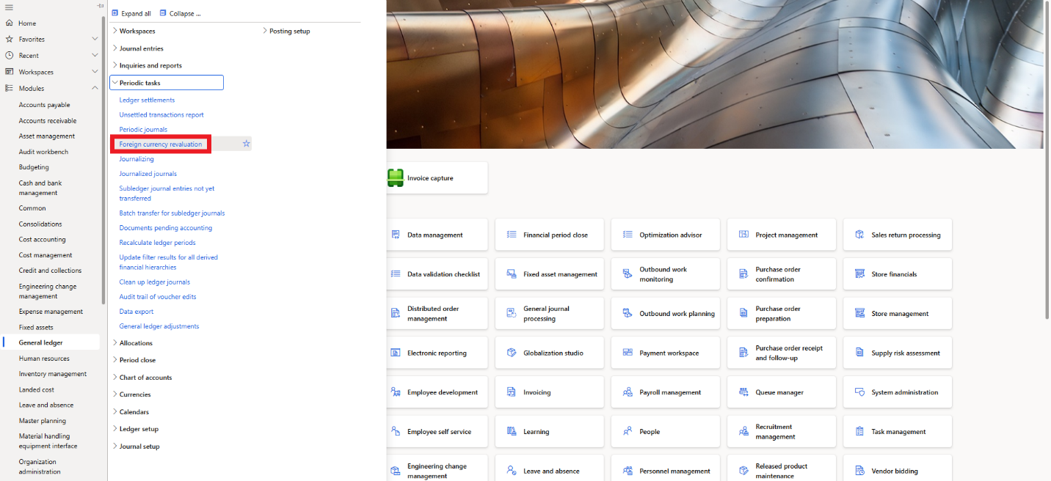

* + - * The **Foreign currency revaluation** page opens displaying the history of each revaluation process.
      * Click on **Foreign Currency Revaluation** at the top.

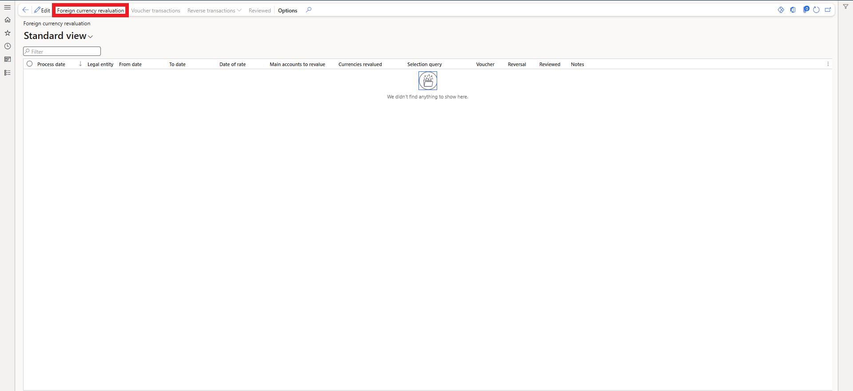

* + - * This will open the parameters window.
      * Enter the **From date** and **To date** values, they define the date interval for calculating the foreign currency balance that will be revalued. When you revalue profit and loss accounts, the sum of all transactions that occur within the date interval are revalued. When you revalue balance sheet accounts, the **From date** is ignored. Instead, the balance to be revalued is determined by going from the beginning of the fiscal year until the **To date**.
      * In the **Date of rate** field enter the date for which the exchange rate should default.
      * In the **Main accounts to revalue** field, select which main accounts to revalue: **All**, **Balance sheet**, or **Profit and loss**. Only main accounts marked for revaluation (on the **Main account** page) will be revalued.
      * The revaluation process can be run for one or more legal entities. In the **Legal entity** field, select the legal entities for which you want to run the revaluation process. The lookup displays the legal entities to which you have access.
      * The revaluation can be executed for one or multiple foreign currencies. In the **Currencies to revalue** field, select the currencies you want to include in the revaluation process. The lookup encompasses all currencies posted within the relevant date range for the type of main account (Balance sheet or Profit and loss) and for the selected legal entities undergoing revaluation. The accounting currency is automatically included in the list, although no revaluation occurs if the accounting currency is chosen.
      * Set **Preview before posting** to Yes to review the result of the General ledger revaluation.
      * If you would like to exclude adjustments that were posted using the **Reporting currency adjustments journal** from the revaluation process, set **Exclude reporting currency adjustments** to **Yes**.
      * If you want to further restrict the range of main accounts, you can use the **filter** option in the **Records to include** tab to define a range of main accounts, or individual main accounts.
      * You can run the process in real time or schedule it to run it in batches using the **Batch processing** option.
      * After filling the parameters, review them to ensure accuracy and completeness. Once verified, you can proceed to run the foreign currency revaluation by clicking **Ok**.

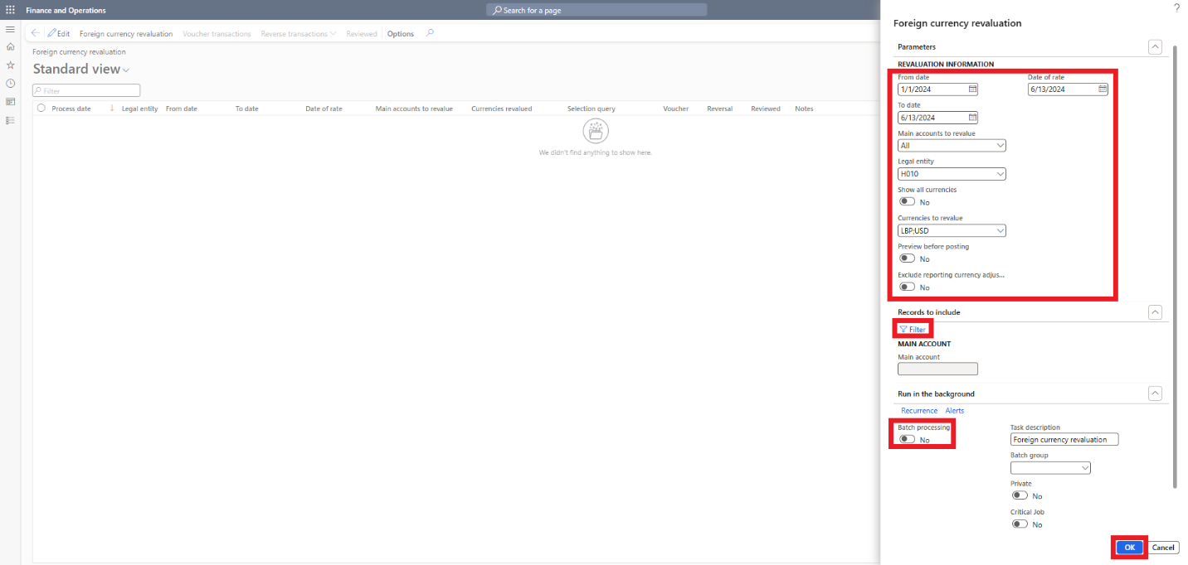



Inter-

Company

Transaction

**8**

# 8. Intercompany Transactions

**Intercompany transactions** in Dynamics 365 Finance and Operations facilitate financial activities between different legal entities within the same organization. These transactions ensure that financial records are accurately maintained across all entities, providing a consolidated view of the organization's finances.

* **Initiation**:
  + An intercompany transaction is initiated in one legal entity (the originating company).
  + This involves creating a journal entry, purchase order, sales order, or another transaction type that impacts another legal entity (the destination company).
* **Intercompany Journal Entries**:
  + When creating a general journal entry for an intercompany transaction, you need to specify the offset company (the destination company).
  + The system generates corresponding entries in both the originating and destination companies.

Example of Intercompany Journal Entries. **Scenario**: C1 is transferring funds to C2

* + - * **Create Journal Entry in C1:**
* Navigate to General ledger > Journal entries > General journals.
* Click New and select the journal name.
* Click Lines to open the journal lines.
* Select C1 in the Company field.
* In the Offset company field, select C2.
* In the Account type field, select Bank.
* In the Account field, specify the bank account from which the funds will be transferred.
* Enter the amount in the credit field and provide a description.
* In the Offset account type field, select Bank.
* Specify the destination bank account in the Offset account field.
* Refer to the 2. GL Journal paragraph for more details about the general journal.
* Validate and post the journal.

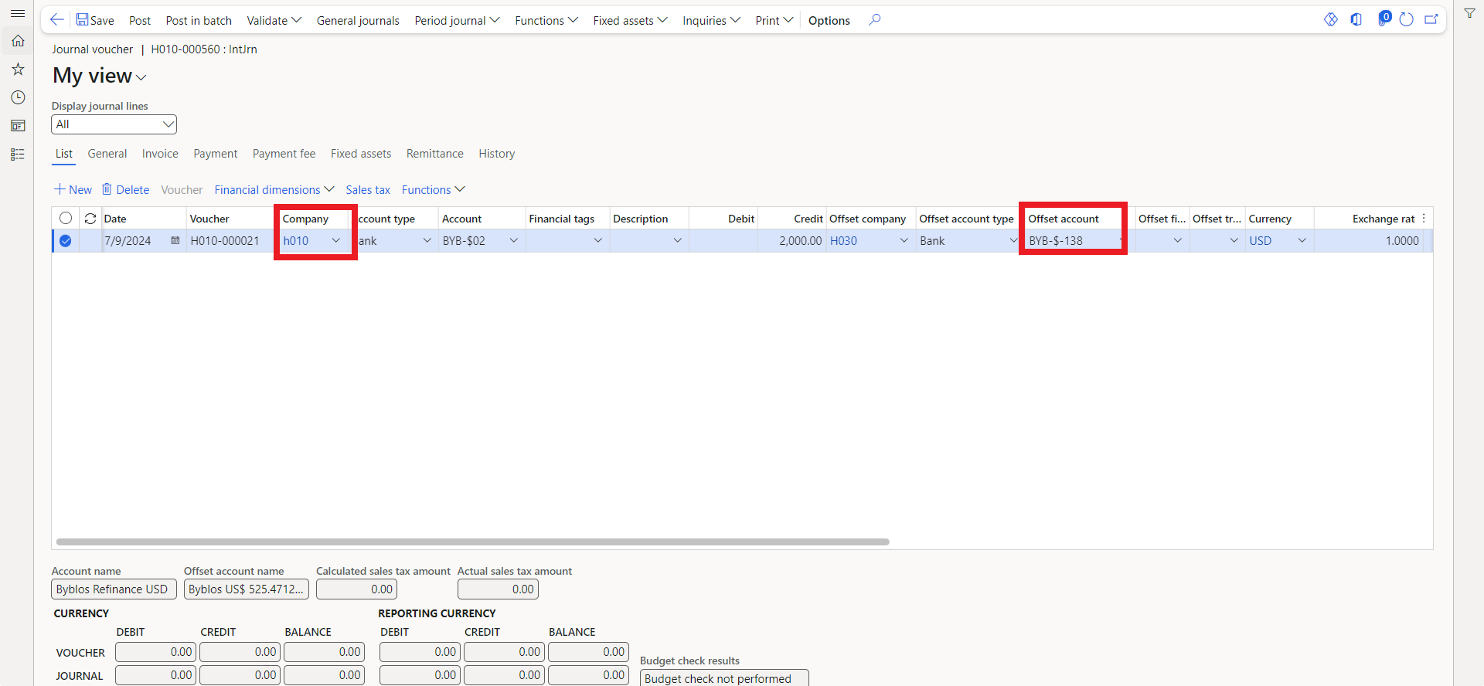

* + - * **System-Generated Entries:**
* C1 (Originating Company):
* Debit: Intercompany receivable account
* Credit: Bank account (from which funds are transferred)

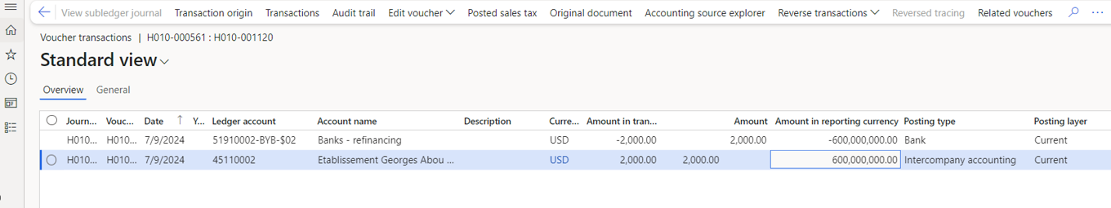

* C2 (Destination Company):
* Debit: Bank account (receiving the funds)
* Credit: Intercompany payable account

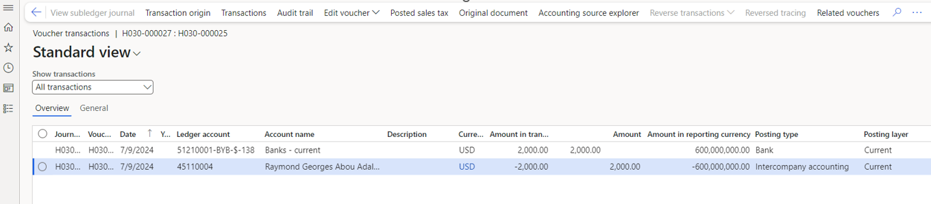

**Key Points to Note**

* **Automatic Posting**: The system automatically posts corresponding entries to the destination company when the originating company posts the transaction.
* **Reconciliation**: Intercompany transactions can be easily reconciled, ensuring that both entities' financial records are accurate and consistent.
* **Currency**: If different currencies are involved, the system handles currency conversion based on predefined exchange rates.

Bank Account Creation



**9**

# 9. Bank account creation

* Navigate to **Cash and bank management > Bank accounts > Bank accounts**.

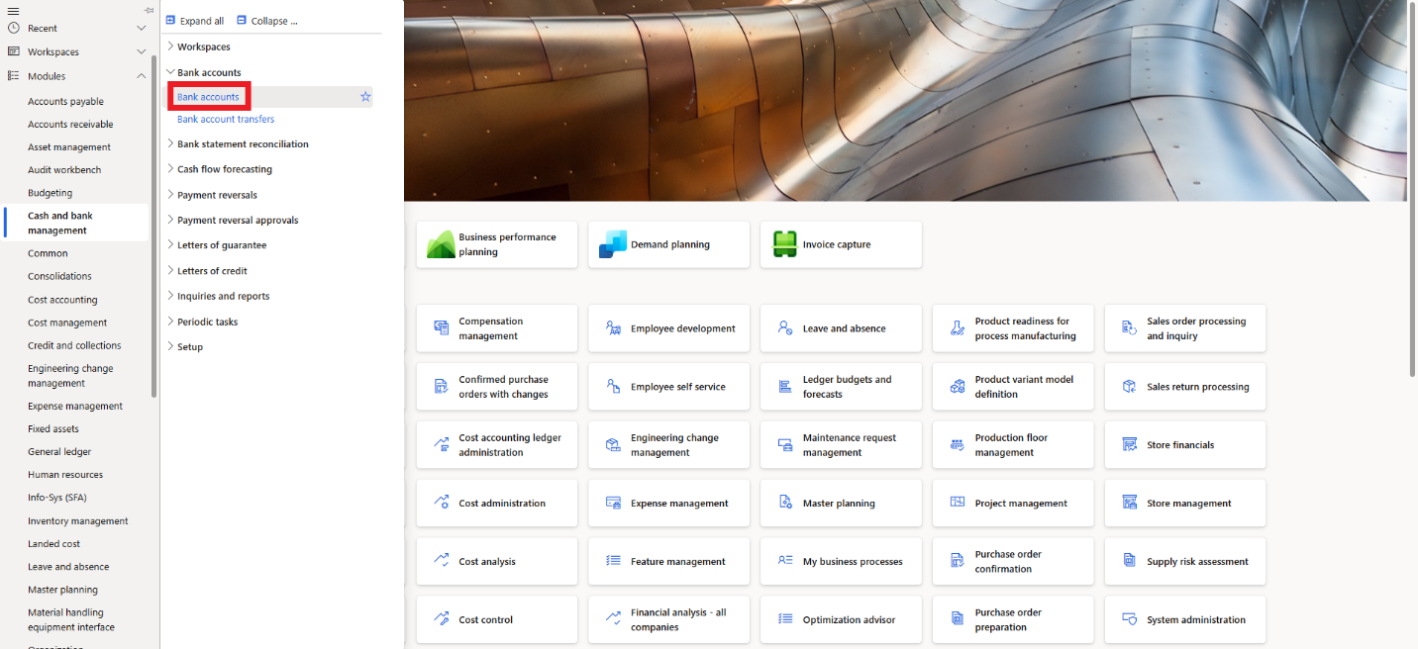

* The Bank Accounts page will open, displaying all the bank accounts available in the system.
* On the Action Pane, click **New** to create a new bank account.

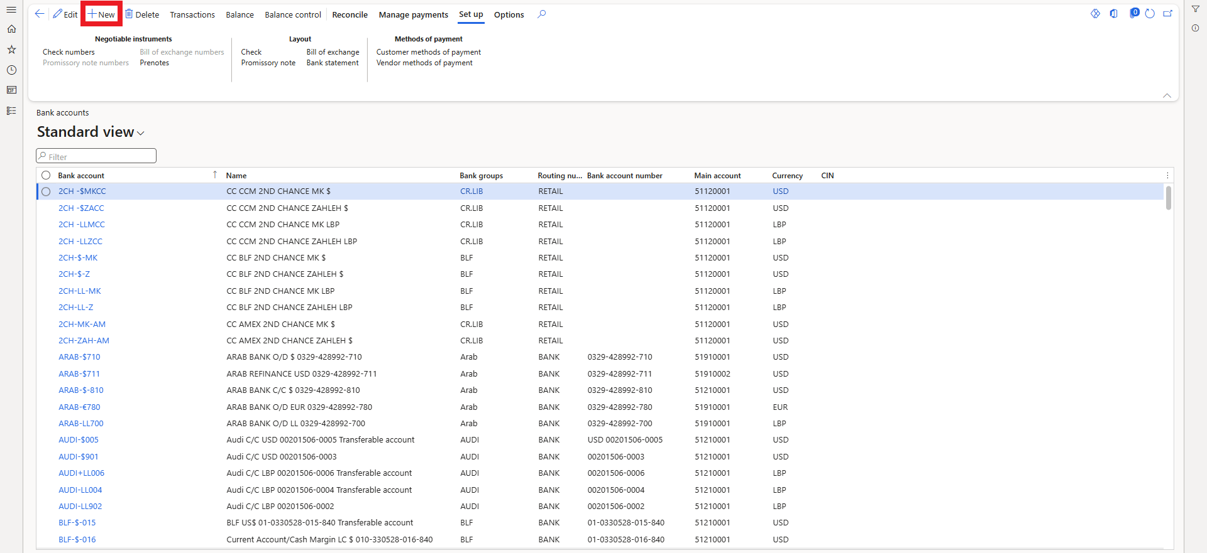

* In the **Routing number** **type** field, select an option. This is the type of routing number that's used for international payments.
* In the **Bank account** field, type a value. This ID will be used to identify the bank account on the vendor record.
* In the **Routing number** field, enter the routing number, it is a unique bank registration number that you use to identify the bank.
* In the **Bank account number** field, type the bank account number that is specified by your bank.
* In the **Main account** field, enter the main account to which all bank account transactions are automatically posted.
* In the **Name** field, enter the bank account name.
* In the **Bank groups** field, select a group.
* In the **Currency** field, select the account currency.
* If you want to put a credit limit for the bank account, enter the amount in the **Credit limit** field.
* In the **SWIFT code** field, you can enter a swift code.
* In the **IBAN** field, you can enter an IBAN code.

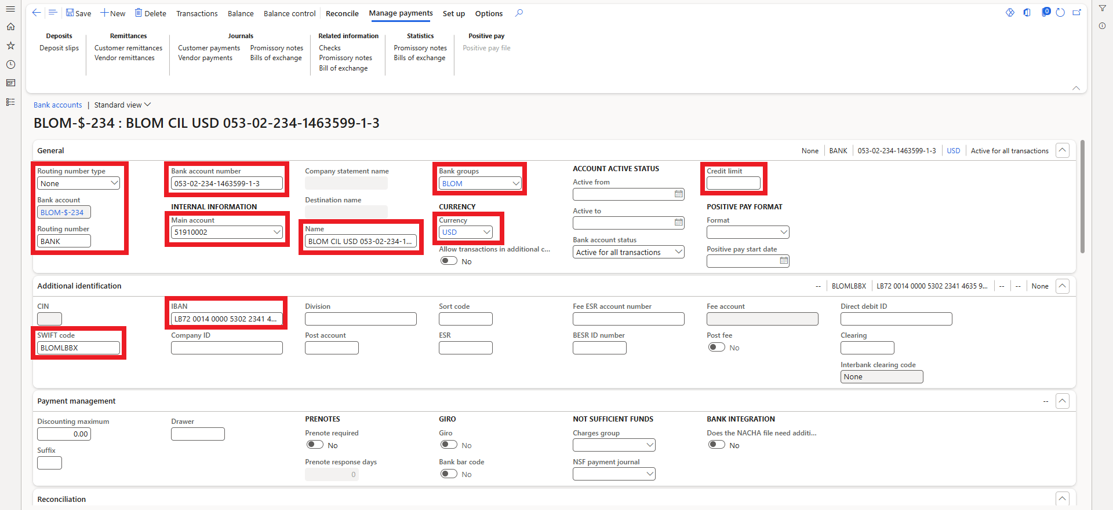

* In the **Address** FastTab you can enter the bank address if needed.
* In the **Contact information** FastTab, you can enter the bank contact information.
* In the **Financial Dimensions** FastTab, enter the appropriate dimensions for this account.
* After filling in all the necessary information, click **Save** in the action pane.

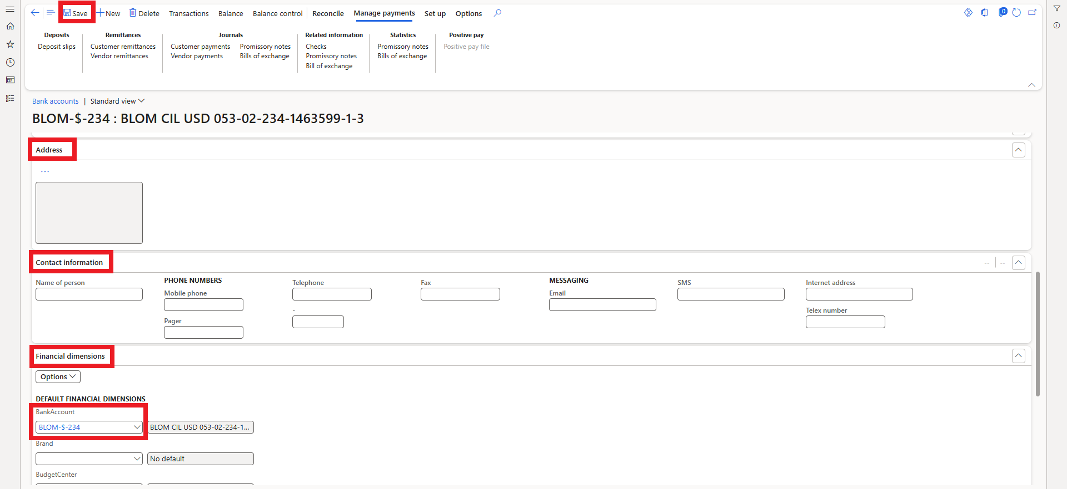

Deposit Slip



**10**

# 10. Deposit Slip

* Navigate to **General ledger > Journal entries > General journals**.



* On the **Action pane**, click **New**.
* In the **Name** field, click the drop-down button to open the lookup, and select the general journal name.
* Select the journal then click **Lines**.

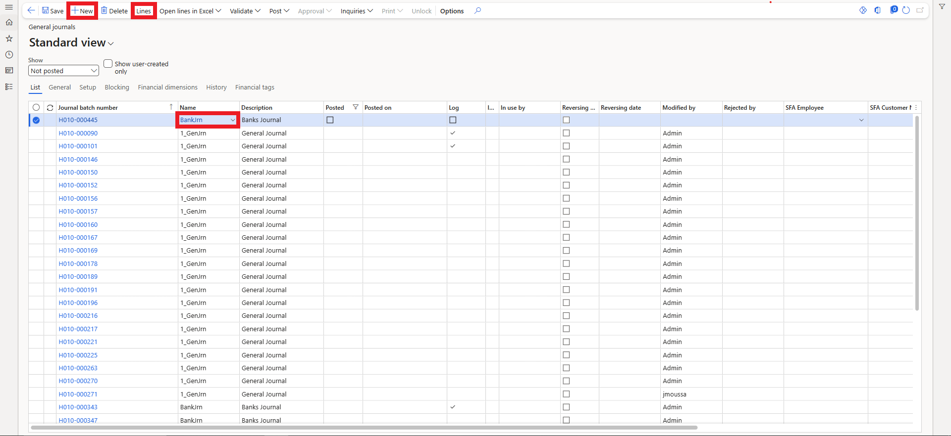

* Create payment lines that include information about the accounts and the amounts. Enter the offset account on each line, the correct bank account for the deposit of the payment. You can refer to section 1.1 for more details about the general journal creation.

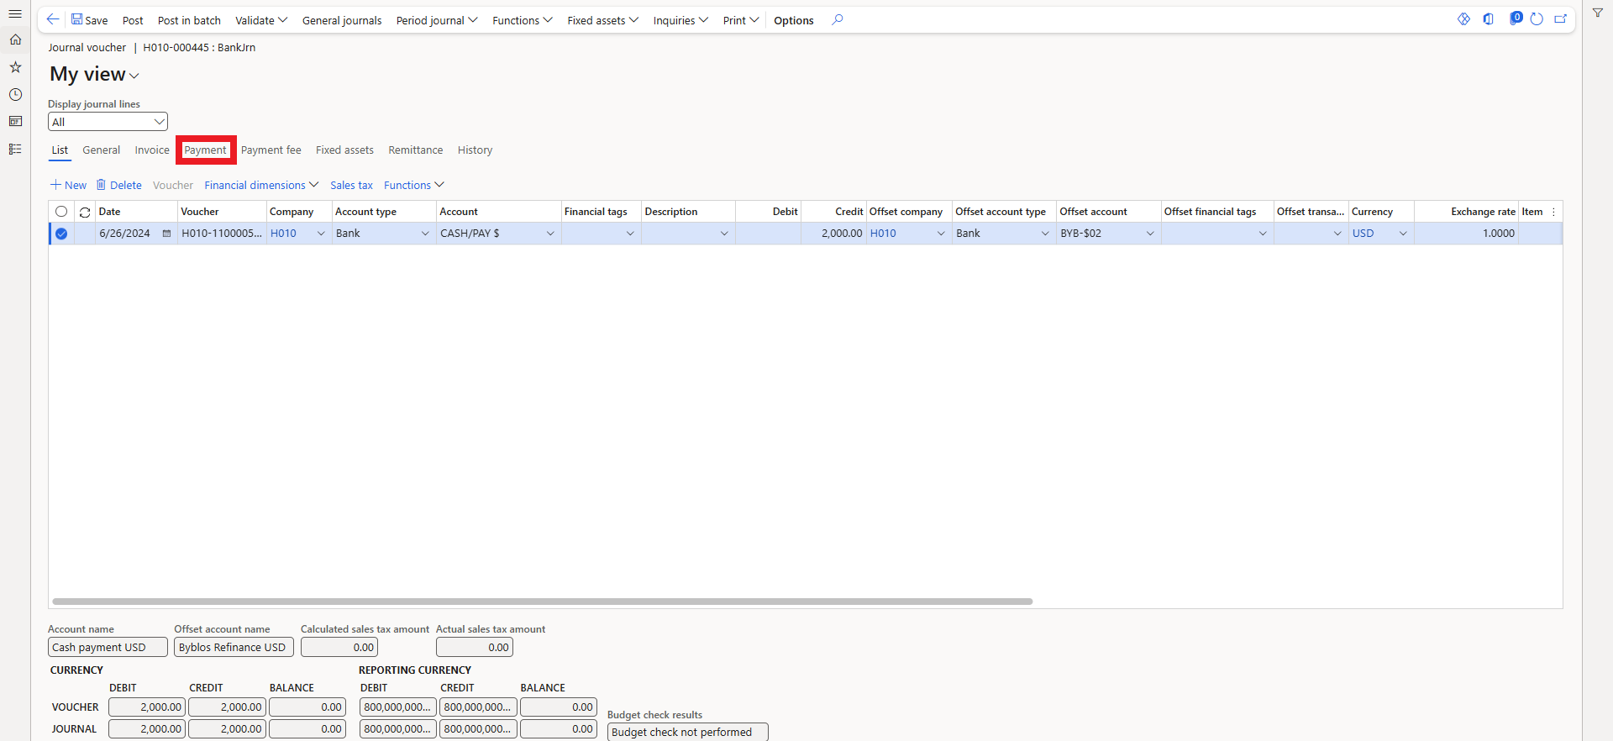

* On the **Payment** tab, select the **Use a deposit slip** check box for all the payment lines to be included on a bank deposit slip.
* Select the **Bank transaction type** that is set up for bank deposits.
* In the **Payment reference** field, enter a reference that pertains to the payment line.
* Repeat these steps for all the payment lines for which the **Use a deposit slip** check box is selected.

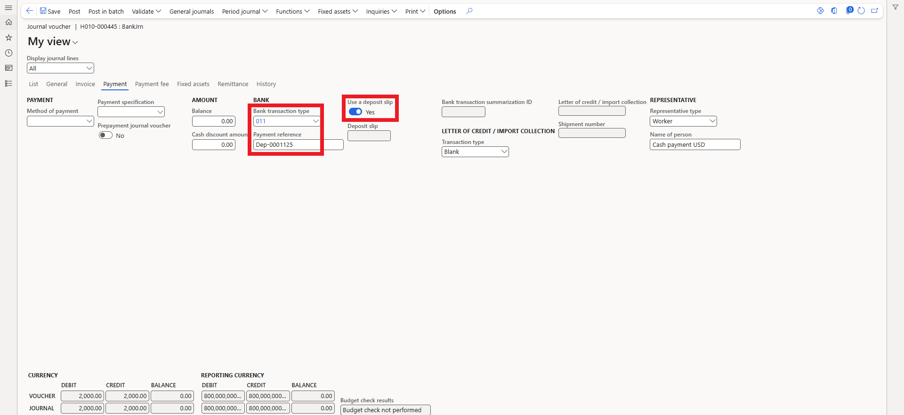

* Click **Validate** > **Validate**, and then click **Post**.

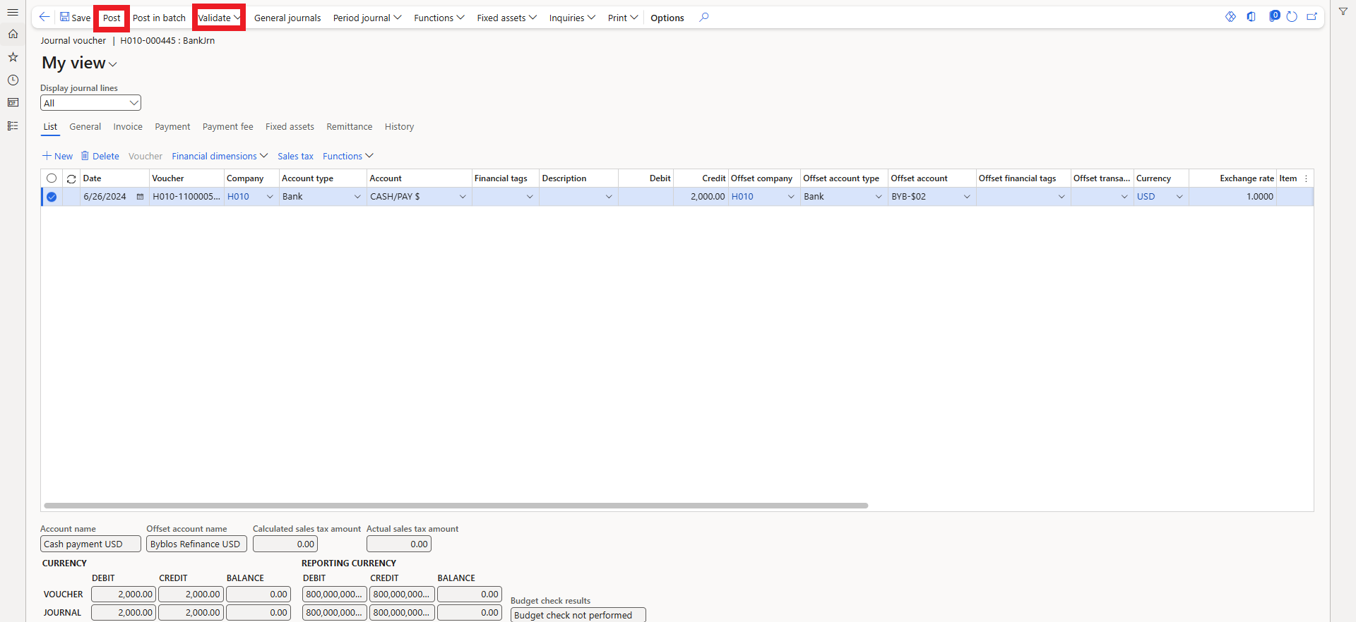

* To prepare a printout of the deposit slips, click **Functions** > **Deposit slip**.

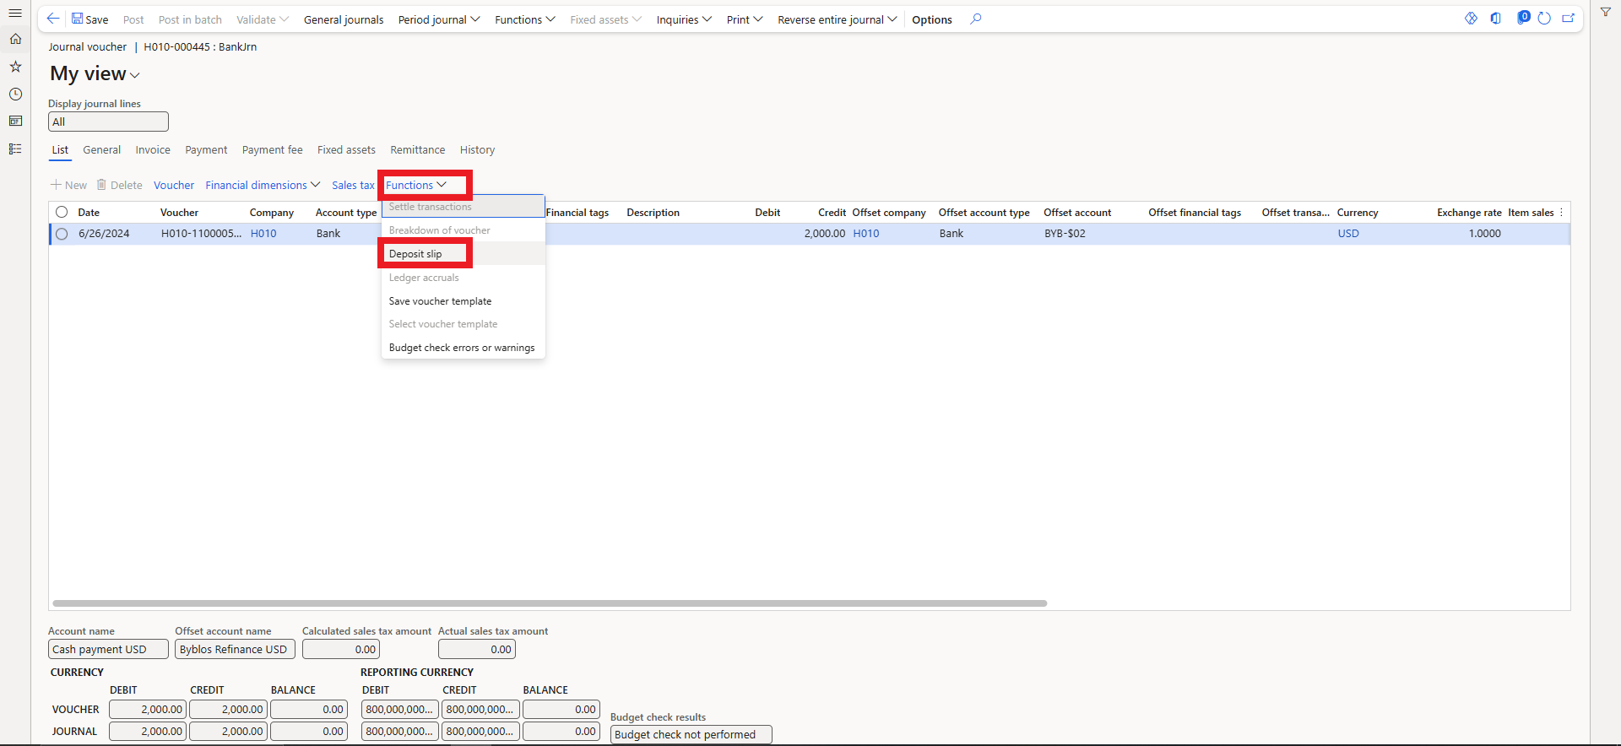

* Select the date to display on the deposit slips, and then click **OK**.

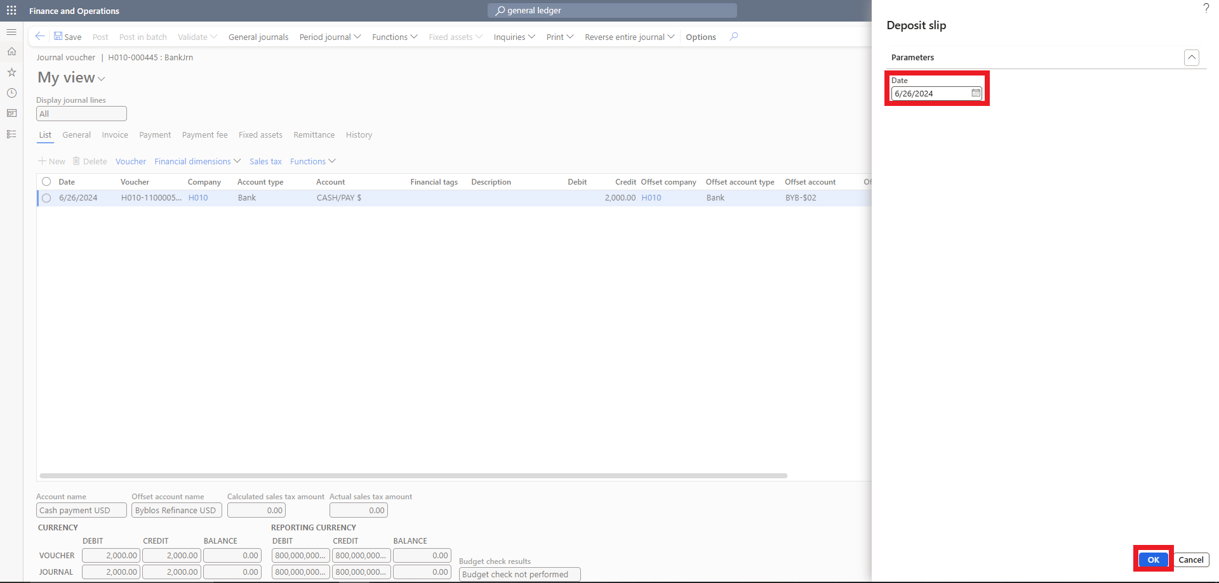

* A dialog box is displayed for each bank account that is listed as an offset account on the journal lines for which the **Use a deposit slip** check box is displayed. In each dialog box.
* You can use the **Change** button to change the print destination of the deposit slip, whether you want to print it to the screen or send it to the printer.
* Click **OK** to print a copy of the deposit slip for the specific bank account.

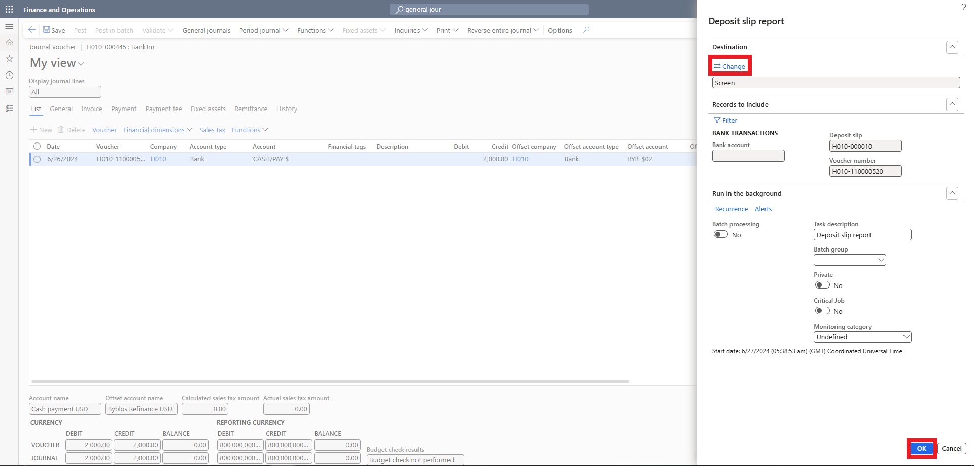

* When the deposit slips are printed, the deposit slip number is entered in the **Deposit slip** field on the **Payment** tab in the **Journal voucher** form for the lines that are included on a deposit slip.

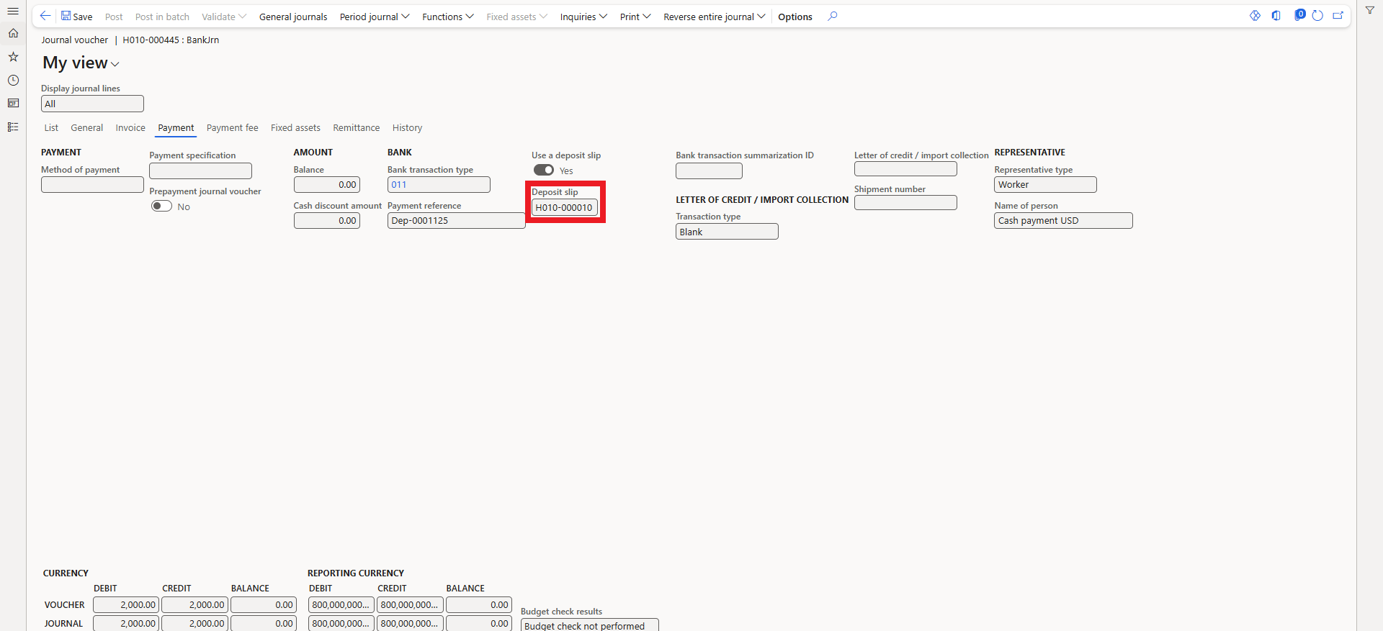

Checks



**11**

# 11. Checks+

## 11.1 Check layout

* Navigate **Cash and bank management** > **Common** > **Bank accounts**.

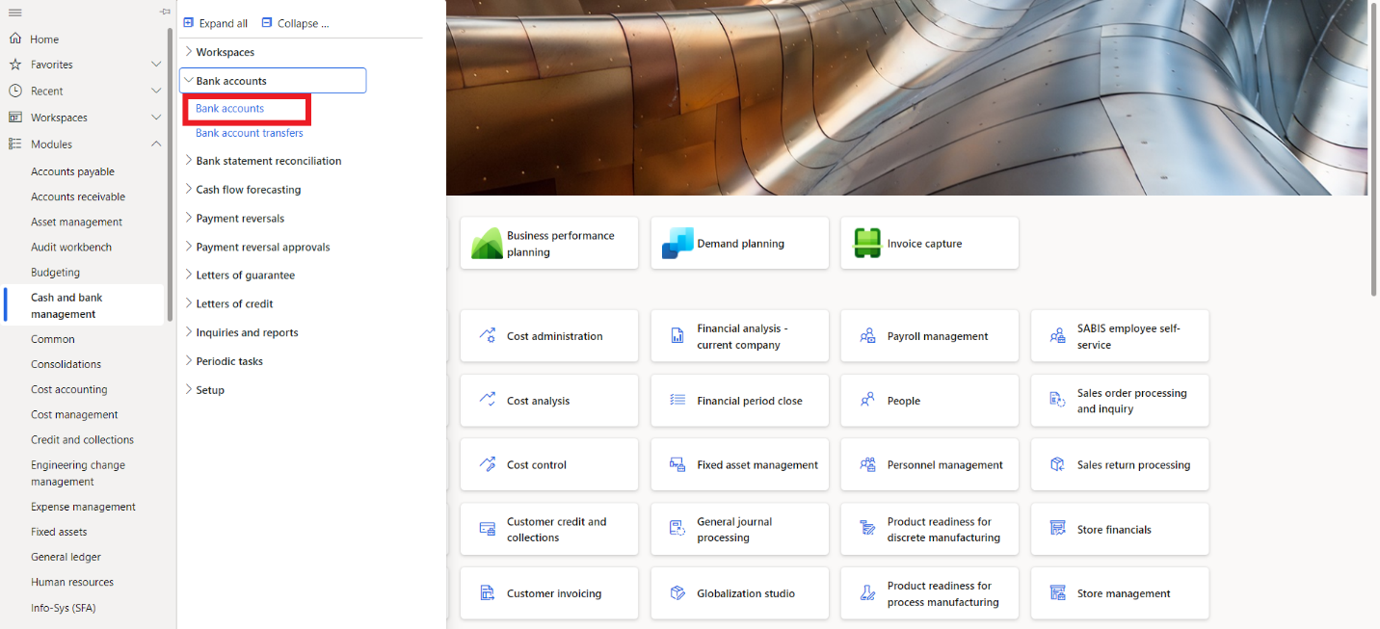

* The system will show you a list of all the bank accounts available, select the bank account you want to create checks for.
* On the **Action Pane**, on the **Set up** tab, click **Check**.

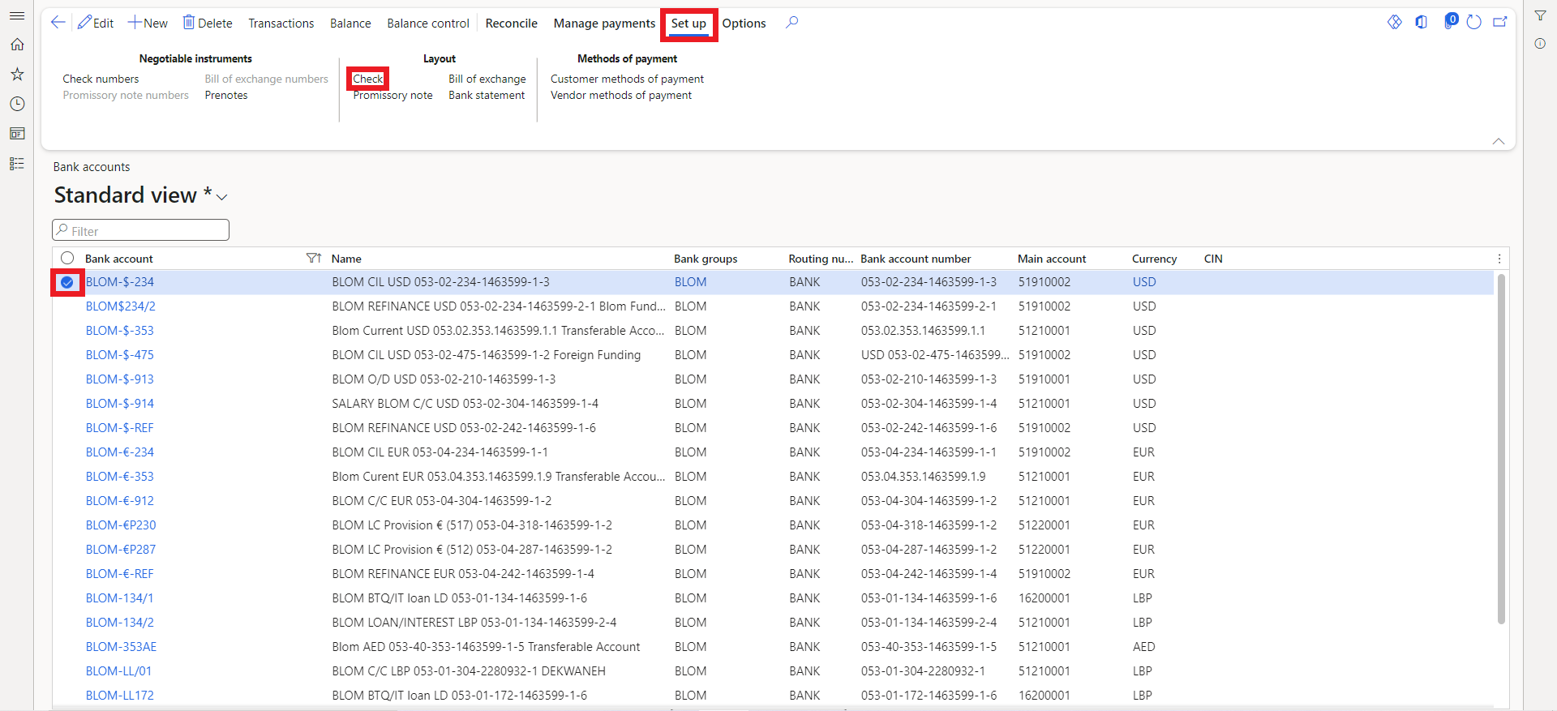

* In the **Check number method** field**,** select the method to use for generating check numbers:
  + **Free**: Use this method when you do not have preprinted checks. Check numbers are automatically proposed when you use checks for payment.
  + **Fixed**: Use this method when you have preprinted checks. Before you can use checks for payment, they must be created by clicking Check numbers on the Action Pane in the Bank accounts form.
* In the **Check form** field, select the check format in which checks will be printed.
* In the **Prefix** field, enter the text to print in front of the amount on the check.
* In the **Check layout** FastTab, enter information in the **Paper length**, **Check start position**, and **Number of slip copies** fields to determine the position of the default check format on the page.
* In the **Setup** FastTab, select the options to print on the check.

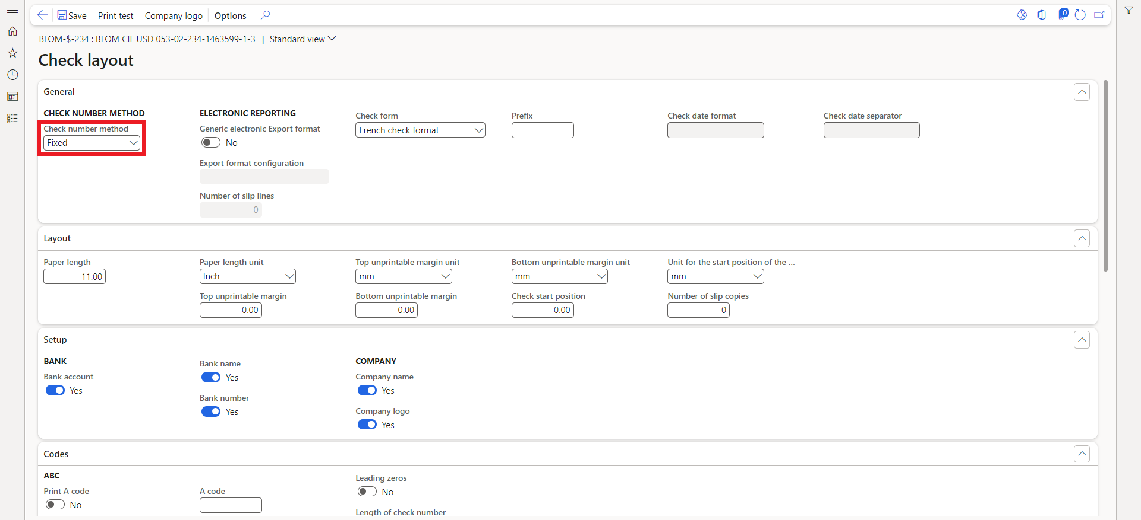

* In the **Codes, Signature, Notes, Copies** FastTabs, specify additional options for the check layout.

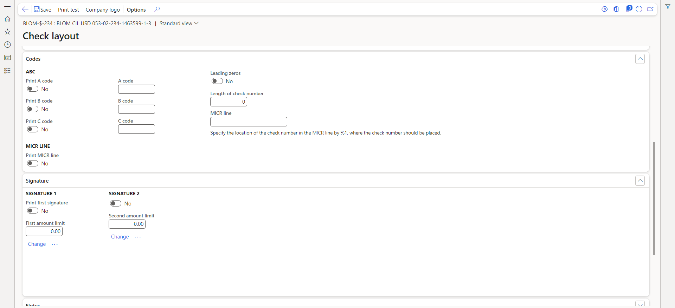

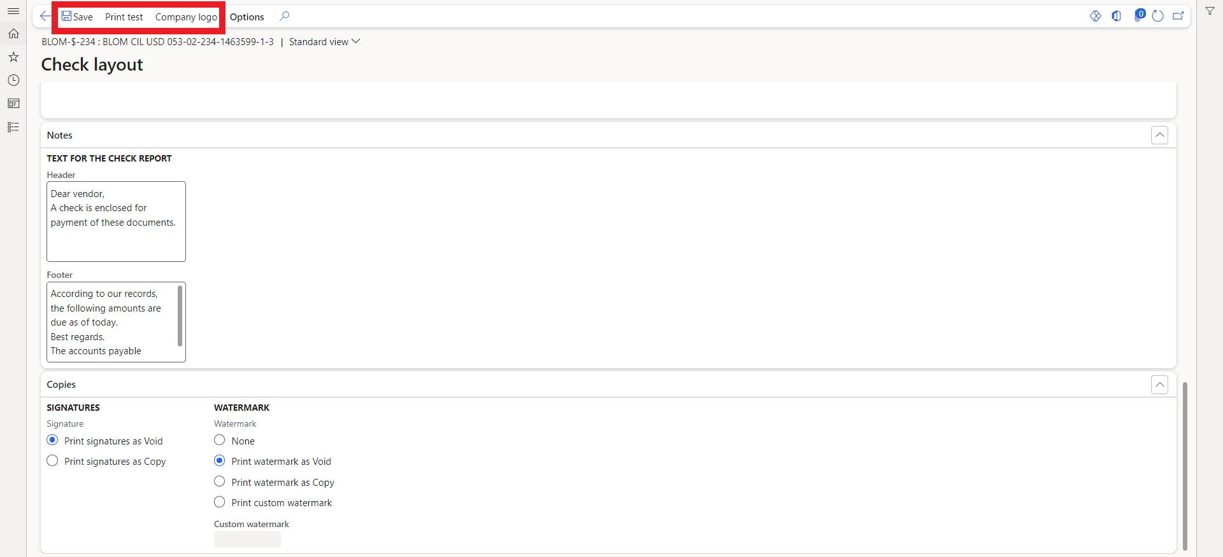

* You can print the company logo on the check, by clicking on the **Company logo** in the action pane to upload the logo.
* Click **Print test** to create a test printout of the check.
* In the **Check layout - print test** form, select the type of check to print negotiable or non-negotiable.
* If necessary, click **Options**, select a printer, and then click **OK**.
* Then, click **OK** to print a test copy of the check layout on plain paper.
* After filling in all the necessary information, click on **Save** in the action pane.

If the **Check number method** is **Fixed,** the checks need to be created before using them, by following these steps:

* Navigate to **Cash and bank management** > **Payment reversals** > **Checks**.
* Click on **Create checks** in the action pane.
* Or from inside the bank account, you can click on **Check numbers** under the **Set up** tab in the action pane.

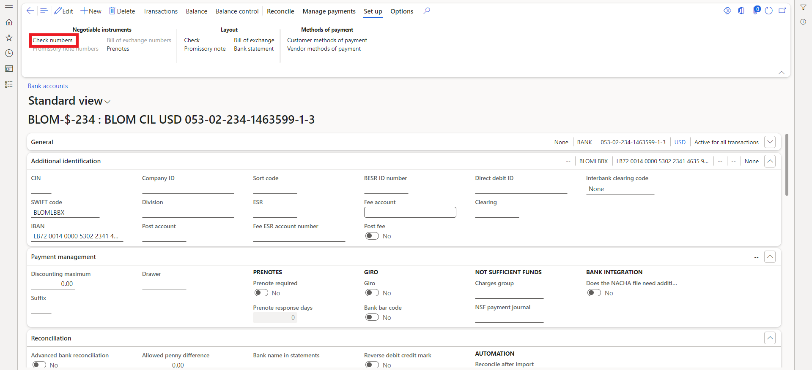

* The system will prompt you to create a check.
* In the **Bank account** field select the bank account which you want to create checks for (if you’re creating checks from inside the bank account, this field is automatically filled).
* In the **Quantity** field enter the Quantity of the checks you want to create.
* In the **From** field, specify the starting number for the sequence of checks.
* Then press **OK**, to create the checks.

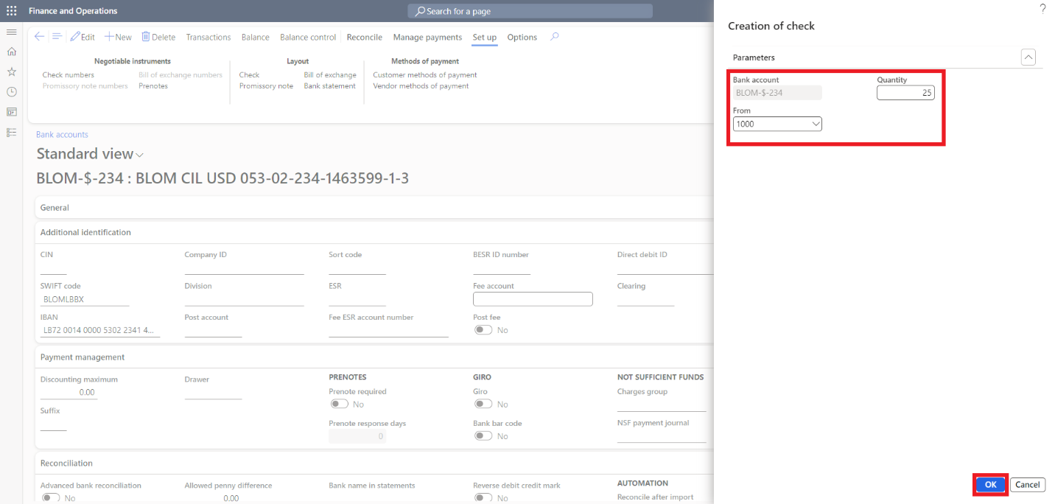

## 11.2. Check payment

To create a check payment, we need to follow these steps while creating a vendor payment journal:

* Navigate to **Accounts payable** > **Payments** > **Vendor payment journal**.

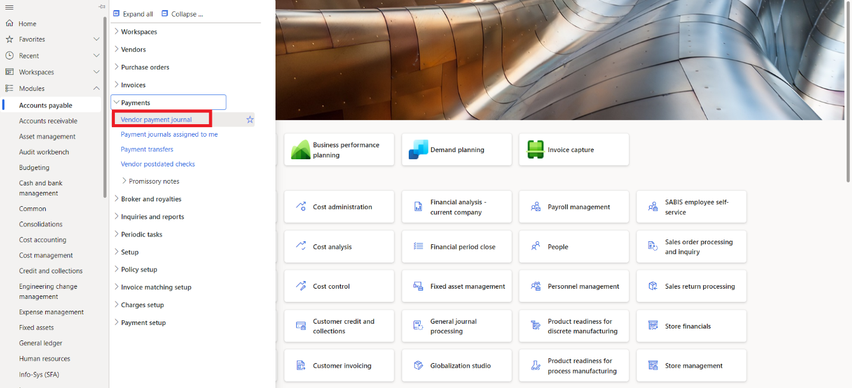

* You will be able to see a list of all the vendor payment journals on D365, both **posted** and **unposted**. You can select which one you want to view from the dropdown field Show by choosing between **posted**, **not posted**, or **all**.
* On the Action pane, click **New**.
* In the **Name** field, enter the journal name or click the drop-down button to open the lookup.
* Optionally, change the value in the **Description** field.
* On the Action pane, click **Lines**.

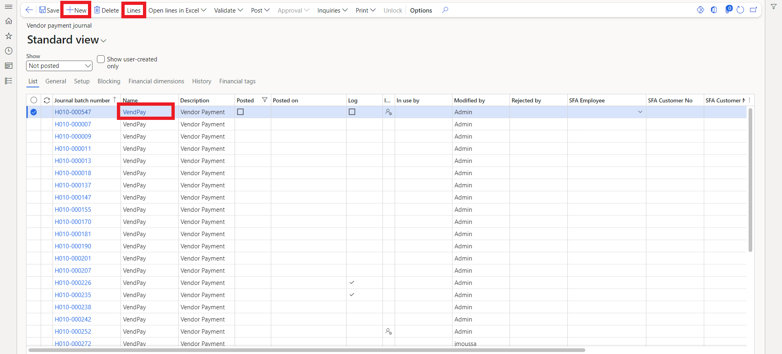

* Enter the posting date in the **Date** field.
* Select the vendor account in the Account field.
* Select a **financial tag**, vendors in this case, and enter a value.
* Optionally, enter a description in the **Description** field.
* Ensure that the **Offset account type** is **bank**, the **method of payment** is **Check** and enter the bank account in the **Offset account** field.
* Now, click on **Settle transactions** to select the invoices or transactions you want to settle.

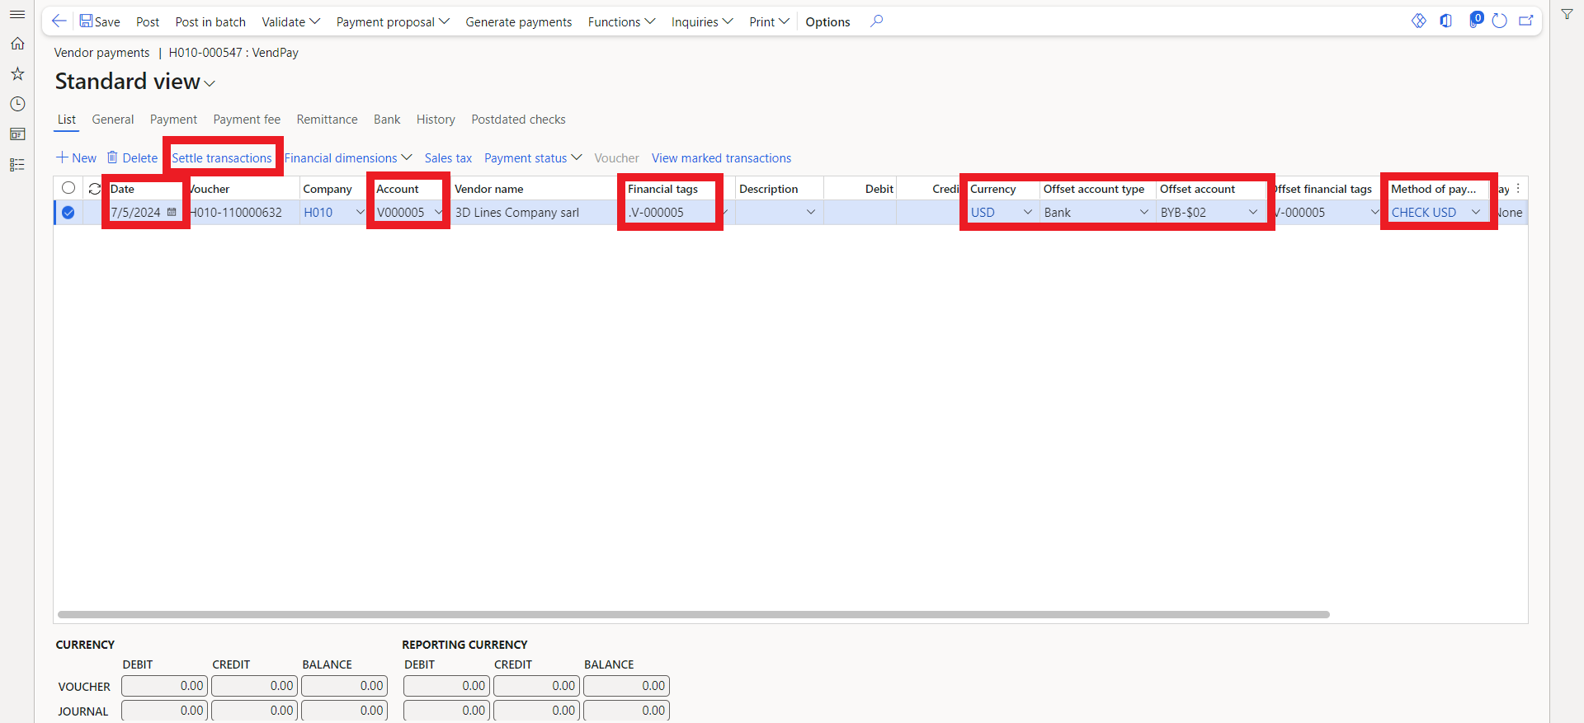

* The system will display all open invoices and transactions for the vendor. Mark the ones you want to pay for by ticking the **Mark** field.
* After selecting the invoices, click **OK**.

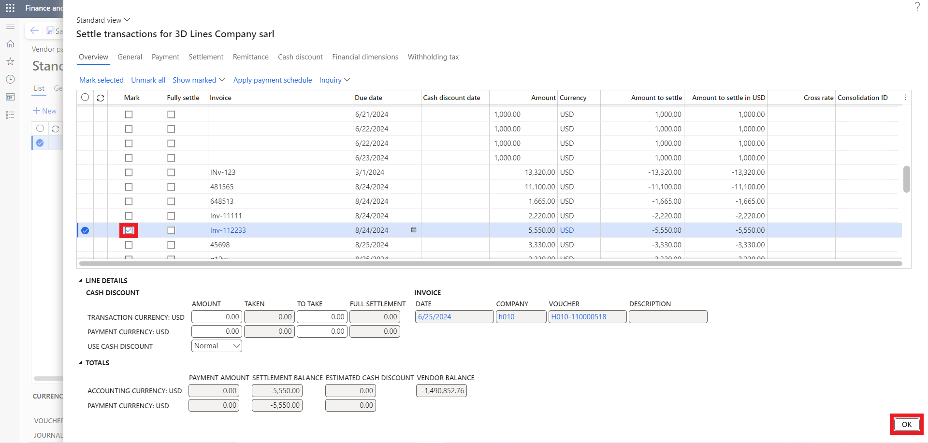

* The system will automatically calculate the payment amount based on the marked invoices.
* Review the payment line and the total amount.
* Click on **Generate payments** to generate check payment.

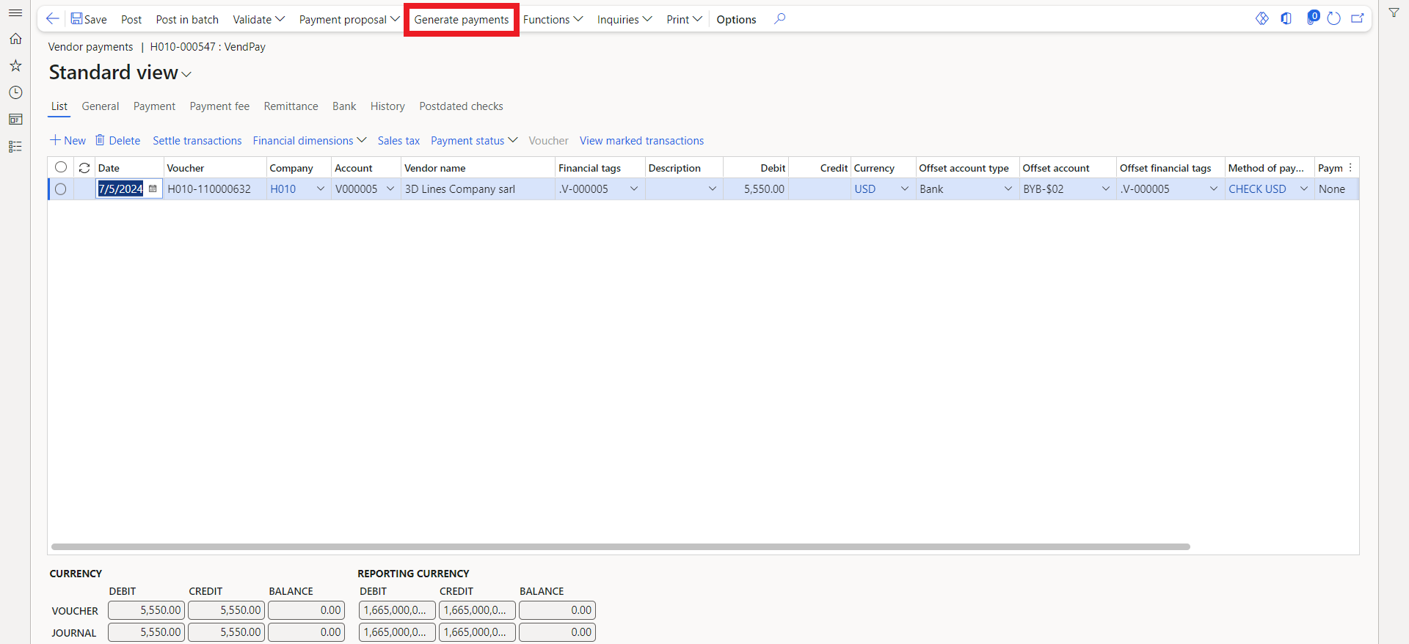

* Ensure the **method of payment** is check.
* Select the **Bank account** from which to generate the payments.
* Click **OK**. Payments will only be generated for payments that match the Method of payment and Bank account you selected.

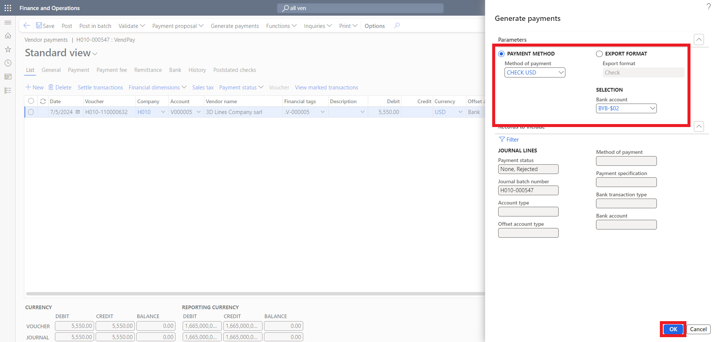

* Then click **OK** again.

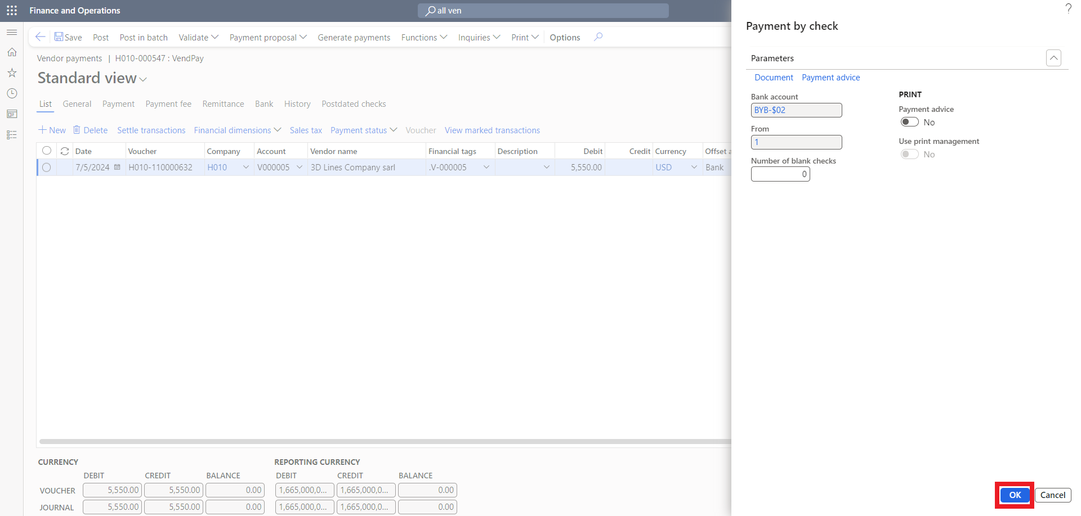

* **Validate** and **Post** the journal to complete the settlement process.

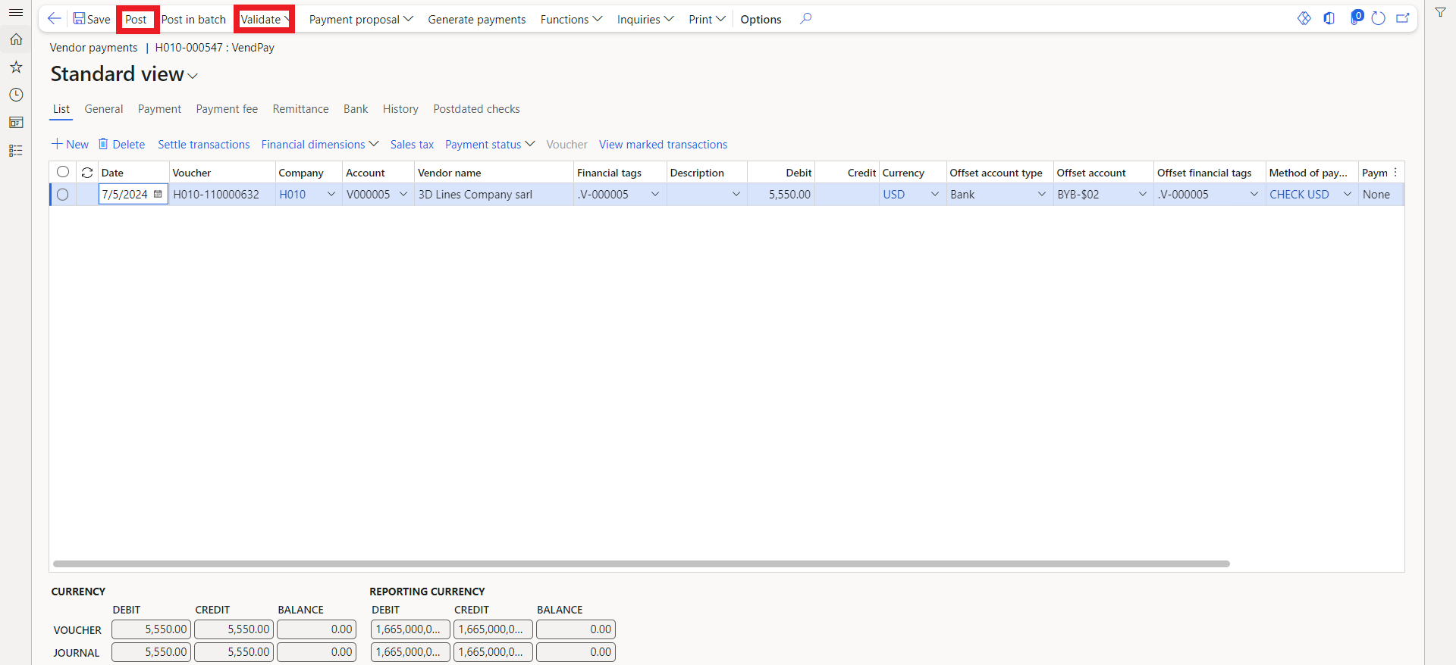

* After posting the Payment journal, you can click on the voucher button over the grid to view the voucher transactions generated.

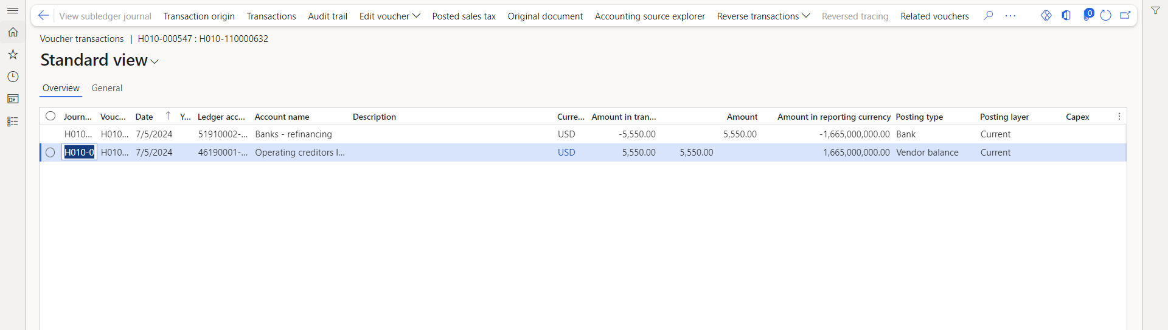

Bank Transfer



**12**

# 12. Bank transfer

* Navigate to **Cash and bank management > Bank accounts > Bank account transfers** or **General ledger > Journal entries > General journals**.



* Click **New** on the Action pane.
* Open the lookup in the **Name** field and select the bank journal name.
* Click **Lines** after selecting the journal.



* Select the legal entity in the **Company** field where the transaction will occur.
* In the **Account type** field, choose **Bank**.
* Specify the bank account from which the funds will be transferred in the **Account** field.
* Enter a description for the transaction in the **Description** field.
* Enter the amount of the journal in either the **Debit** or **Credit** fields.
* If it's an intercompany bank transfer, enter the **Offset company**. This field is used for intercompany transactions that require offsetting in another company's general ledger.
* Select **Bank** in the **Offset account type** field.
* Choose the bank account that will receive the transfer in the **Offset account** field.
* Select the currency of the transaction in the **Currency** field.
* **Validate** the journal in the Action pane, then click **Post** to finalize and post the journal entry.

# 13. Bank Reconciliation

* Navigate to **Cash and bank management > Bank accounts > Bank account**

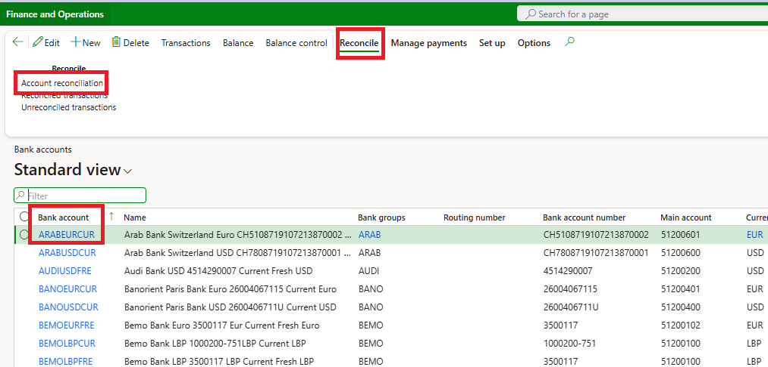

* Select the bank that you want to reconcile > press **Reconcile** > **Account Reconciliation**
* Press **New**
* Enter the **Bank statement date**, **Bank statement** Reference, **Currency**, **Ending balance** value
* Press **Save,** the transaction button will be enabled
* Press **Transactions**

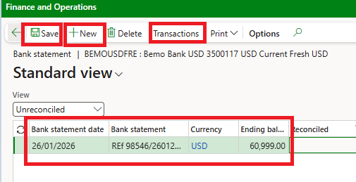

* Mark the accurate lines and then press **mark selected as cleared,**
* Create **New** if needed, define the **bank transaction type, amount, bank amount** as well as the related **main account**
* Ensure the **Unreconciled** is zero
* Press **Reconcile account**

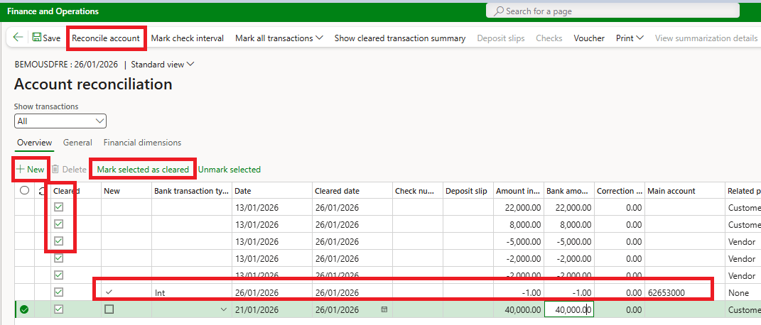



* The system will display the reconciliation message.

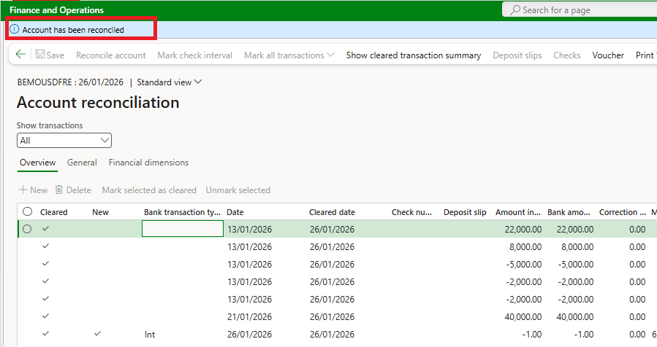

Reports



# 14. Reports

**144**

|  |  |
| --- | --- |
| Module | Reports |
| General Ledger | Voucher transactions |
| General Ledger | Audit trail |
| General Ledger | Posted sales tax |
| General Ledger | Posted withholding tax |
| General Ledger | Audit trail |
| General Ledger | Chart of accounts |
| General Ledger | Management Reporter |
| General Ledger | Sales tax payments |
| General Ledger | General journal entries that have not been posted |
| General Ledger | Posted transactions by journal |
| General Ledger | Print journal |
| General Ledger | Bank |
| General Ledger | Open ledger transactions |
| General Ledger | Transaction origin |
| General Ledger | Account statement by currency |
| General Ledger | Transaction list by date |
| General Ledger | Sales tax list |
| General Ledger | Sales tax transactions |
| General Ledger | Detailed trial balance |
| General Ledger | Summary trial balance |
| General Ledger | Withholding tax transactions |
| Cash and Banks | Bank transactions |
| Cash and Banks | Balance control |
| Cash and Banks | Bank remittance |
| Cash and Banks | Letters of guarantee inquiry |
| Cash and Banks | Transactions |
| Cash and Banks | Bank statement |
| Cash and Banks | Payment summary by date |
| Cash and Banks | Deposit summary by date |
| Cash and Banks | Bank payment summary by vendor |
| Cash and Banks | Deposit summary by customer |
| Cash and Banks | Bank account balance |
| Cash and Banks | Payment advice |
| Cash and Banks | Deposit slip |
| Cash and Banks | Letters of credit/guarantee |
| Cash and Banks | Letter of guarantee expiration dates Letter of guarantee application form Bank facilities and utilization Reconciliation |
| Cash and Banks | Unreconciled bank transactions |
| Cash and Banks | Print statement |